1.a

**Tableau Architecture:**

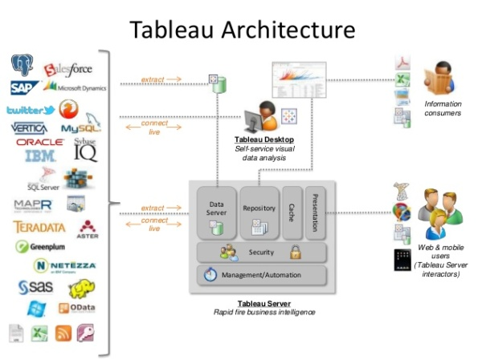

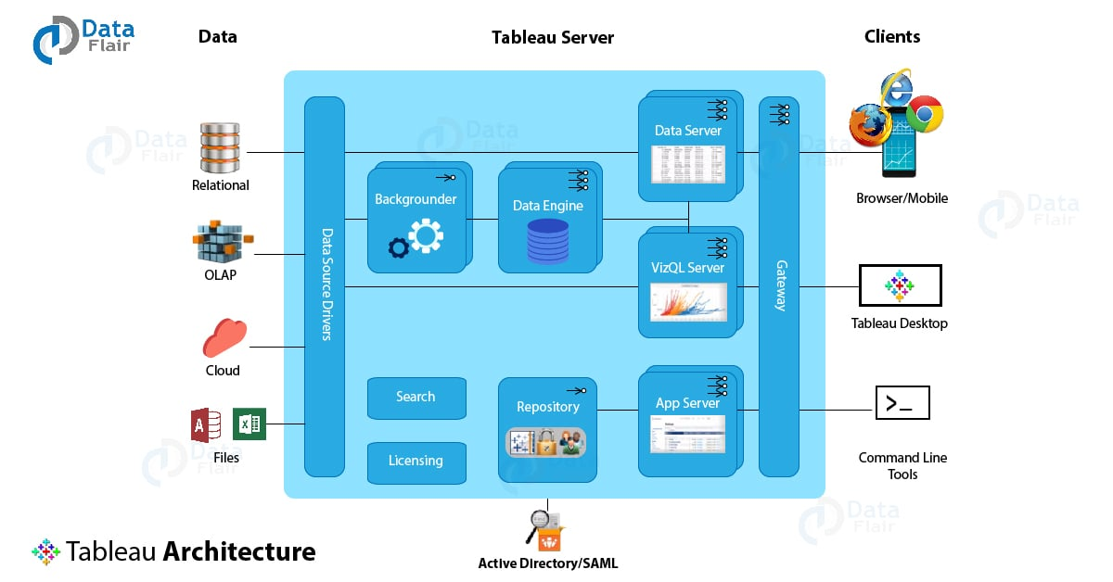

#### **1. Gateway**

Gateway is a kind of web-server that helps clients communicate to the server via HTTP or https. The server receives incoming client requests and directs them to the appropriate server for action. A gateway handles processes such as load balancing, traffic routing, URL rewriting, serving static files to clients, serving multi-thread processes etc. The gateway server used by Tableau is Apache Tomcat.

#### **2. Application Server**

Gateway interacts primarily with the application server, also known as a workgroup server. The application server deals with login processes, domain authentication, data authorization, user or group permission management, content searches, etc. It works in close association with the server’s repository and handles the data access operations. Also, it renders processes related to the user interface other than the visualizations which are the work of the VizQL server. The user interface is the page that gives the users an overview of the workbooks and projects they have access to.

#### **3. Repository**

The repository in Tableau Server stores server metadata related to users, permissions, assignments, groups, and projects. Along with the metadata, it stores visualizations in flat files (TWS, TDS), and performance data for auditing. Whenever a server service or component demands for metadata, it is provided from the repository. Also, it cooperates with the active directory to provide useful information to the app server for login verification processes.

#### **4. VizQL Server**

It is an important component of Tableau Server as it is responsible for loading all the visualizations that you see and work with on Tableau. It has an in-built caching for performance improvement and editing tasks. Whenever a user requests a visualization or wishes to update an existing one, the request received by VizQL is first converted into an SQL statement and sent down to the data sources via respective data source drivers. The requested data sent back from the data source comes to the VizQL server again, where it is processed with some final touches of additional calculations and sent to the user. Any new visualization coming from the data source is cached in the VizQL for further use.

#### **5. Data engine**

The data engine is another efficient component which handles processes related to [**Tableau data extract (TDE)**](https://data-flair.training/blogs/tableau-data-extract/). It is invoked only when a query is shot, which involves data from TDE. The data engine stores multiple TDEs and can run on multiple servers maximum 2). It also attends multiple requests parallelly at a given point of time. The data engine hosts the piece of data in-memory extracted from the TDE upon getting a request from the user.

#### **6. Backgrounder**

Backgrounder is an essential multi-process, a multi-process element that manages schedules for information refreshing and ensures proper functioning of the Tableau Server and Data Engine.

#### **7. Data Server**

The data server helps in centralizing metadata management, driver deployment, and extract management. It also contributes to access control and serves as a proxy to the data sources. It hosts user queries and requests to prevent users from directly accessing the data source.

#### **8. Search and License**

Two other important components are search and license. The search component manages the search indexing for the data in the repository. Whereas, the license component is responsible for the licensing and configuration of the Tableau server. Both these services run on the primary server of the Tableau’s server cluster.

**Tableau Installation:**

**Step 1)** Go to <https://public.tableau.com/en-us/s/download> on your web browser. Now you need to enter your email id and click on “**DOWNLOAD THE APP**” button.

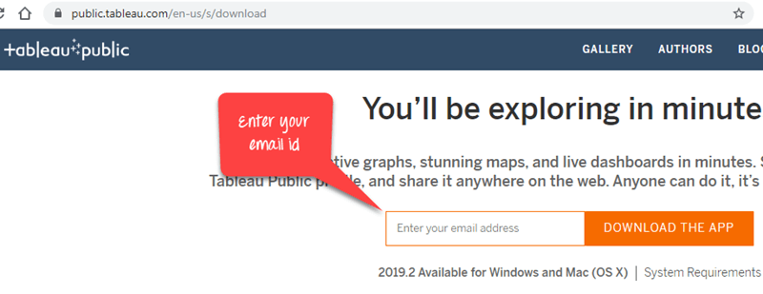

**Step 2)** This will start downloading the .exe file for Windows by default, and you can see the downloading process in the bottom left corner of the website.

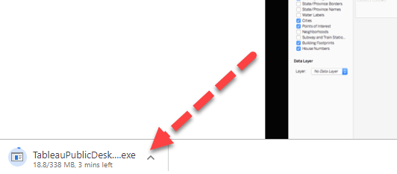

**Step 3)** Open the downloaded file. Accept the terms and conditions and click on “Install” button.

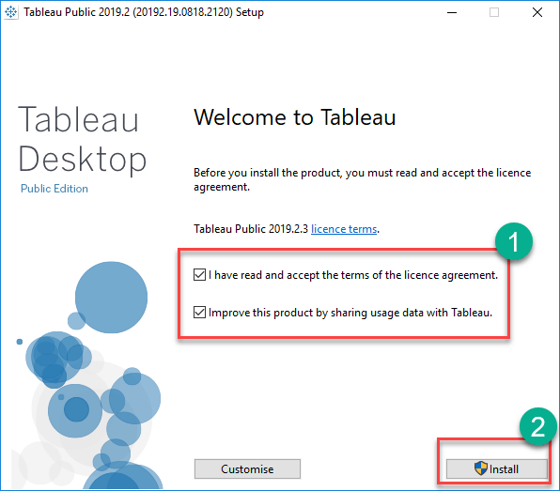

**Step 4)** After installation Start Screen of Tableau is shown

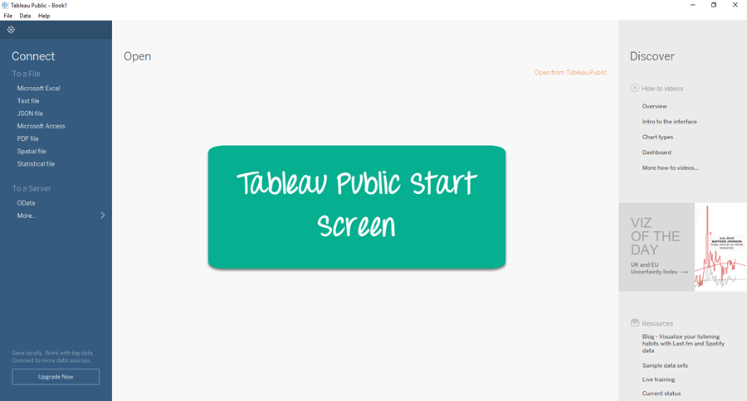

## Download and Install Tableau Desktop

**Step 1)** Go to <https://www.tableau.com/products/desktop> on your web browser.

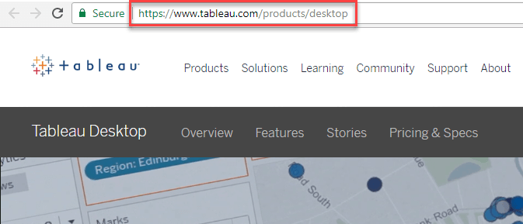

**Step 2)** Click on the “TRY NOW” button shown in the top right corner of the website.

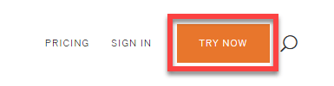

**Step 3)** It will redirect to the page where you need to enter your email id and click on “**DOWNLOAD FREE TRIAL**” button.

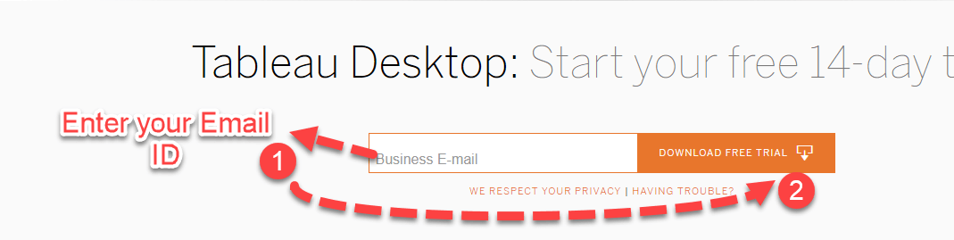

**Step 4)** This will start downloading tableau latest version. An .exe file for Windows is downloaded, and you can see the downloading process in the bottom left corner of the website.

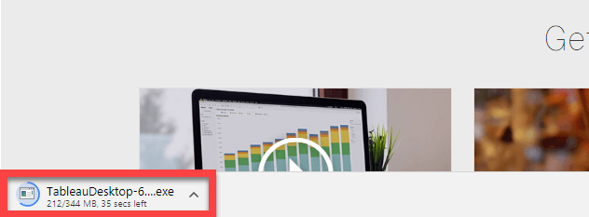

**Step 5)** Open the downloaded file. Check in to accept the terms and conditions and click on “Install” button.

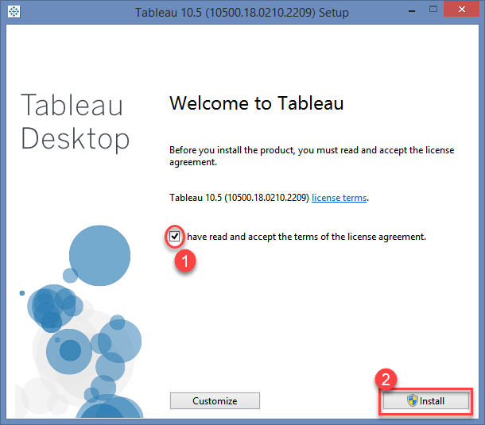

**Step 6)** A optional pop-up message will be shown to get the approval of Administrator to install the software. Click on “Yes” to approve it. Installation of the Tableau Desktop on Windows system starts

**Step 7)**Once the installation is completed, open the Tableau Desktop software.

**Step 8)** In the Registration window

1. Click on Activate Tableau and entire your license details
2. If you do not have a license, enter your credentials
3. Click on Start Trial now

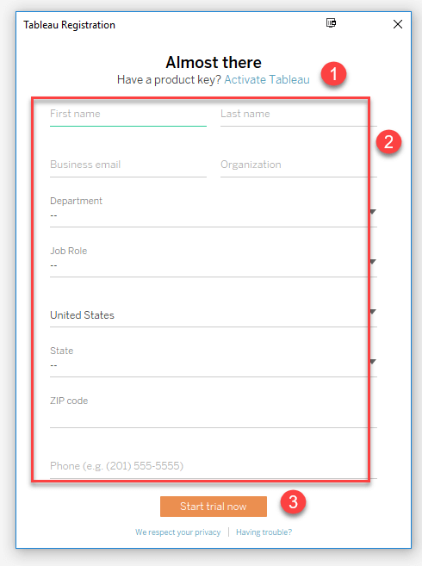

**Step 9)** Wait for registration to complete

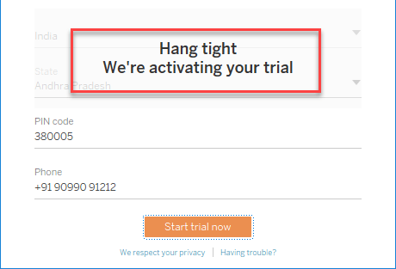

**Step 10)** Start Screen of Tableau is shown

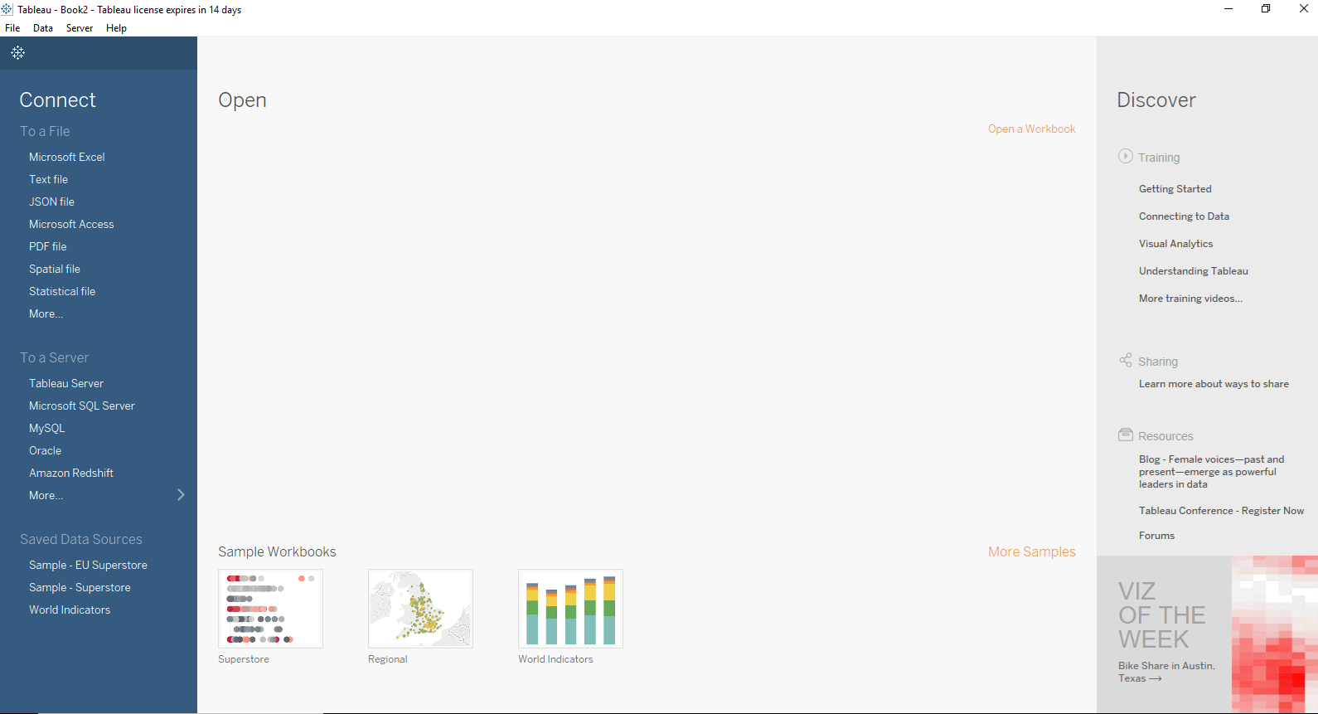

Now you are all set to use the Tableau Desktop in your windows system.

**Tableau Terminology:**

### a. Aliases

An elective name that you can appoint to a field or to a measurement part.

### b. Bin

A user-defined grouping of measures in the data source.

### c. Bookmark

A .tbm document in the bookmarks envelope in the tableau archive that contains a solitary worksheet. Much like web program bookmarks, .tbm documents are a helpful method to rapidly show distinctive investigations.

### d. Calculated Field

Another field that you make by utilizing an equation to alter the current fields in your information source.

### e. Cross Tab

A text table view. Use text tables to display the numbers associated with dimension members.

### f. Dashboard

A combination of several views arranged on a single page. Use dashboards to compare and monitor a variety of data simultaneously.

### g. Data Pane

A sheet on the left half of the exercise manual that shows the fields of the information sources to which tableau is associated. The fields are partitioned into measurements and measures. The information sheet additionally shows custom fields, for example, figurings, binned fields, and gatherings. You manufacture perspectives of your information by dragging fields from the information sheet onto the different racks that are a piece of each worksheet.

### h. Data Source Page

A page where you can set up your information source. The information source page, for the most part, comprises of four principle zones − left sheet, join territory, see zone, and metadata zone.

### i. Filters Shelf

A shelf on the left of the workbook that you can use to exclude data from a view by filtering it using measures and dimensions.

### j. Extract

A spared subset of an information source that you can use to enhance execution and examine disconnected. You can make a concentrate by characterizing channels and restrains that incorporate the information you need in the concentrate.

### k. Dimension

A field of clear-cut information. Measurements normally hold discrete information, for example, progressive systems and individuals that can’t be accumulated. Cases of measurements incorporate dates, client names, and client sections.

### l.  Format Pane

A sheet that contains arranging settings that control the whole worksheet, and also singular fields in the view. Whenever open, the format sheet shows up on the left half of the exercise manual.

### m. Level of Detail (LOD) Expression

A sentence structure that backings total at dimensionalities other than the view level. With the level of detail art.

### n. Marks

A piece of the view that outwardly speaks to at least one columns in an information source. A stamp can be for instance, a bar, line, or square. You can control the sort, shading, and size of imprints.

### o. Marks Card

A card to the left of the view, where you can drag fields to control mark properties such as type, color, size, shape, label, tooltip, and detail.

### p. Pages Shelf

A rack to one side of the view that you can use to part a view into an arrangement of pages in light of the individuals and qualities in a discrete or ceaseless field. Adding a field to the pages rack resembles adding a field to the rows rack, with the exception of that another page is made for each new line. Inculcations, you can join at least one measurements to any total articulation.

### q. Rows Shelf

A rack at the highest point of the exercise manual that you can use to make the lines of an information table. The rack acknowledges any number of measurements and measures. When you put a measurement on the rows rack, Tableau makes headers for the individuals from that measurement. When you put a measure on the Rows rack, Tableau makes quantitative tomahawks for that measure.

### r. Shelves

Named regions to one side and best of the view. You manufacture sees by setting fields onto the racks. Some racks are accessible just when you select certain check composes. For instance, the shape rack is accessible just when you select the shape check to write.

### s. Workbook

A file with a .twb extension that contains one or more worksheets (and possibly also dashboards and stories).

### t. Worksheet

A sheet where you build views of your data by dragging fields onto shelves.

So, this was all about Tableau Terminology Tutorial. Hope you like our explanation.

**Tableau Navigation:**

1. File menu
2. Data menu
3. Worksheet menu
4. Dashboard menu
5. Story menu
6. Analysis menu
7. Map menu
8. Format menu
9. Server menu

[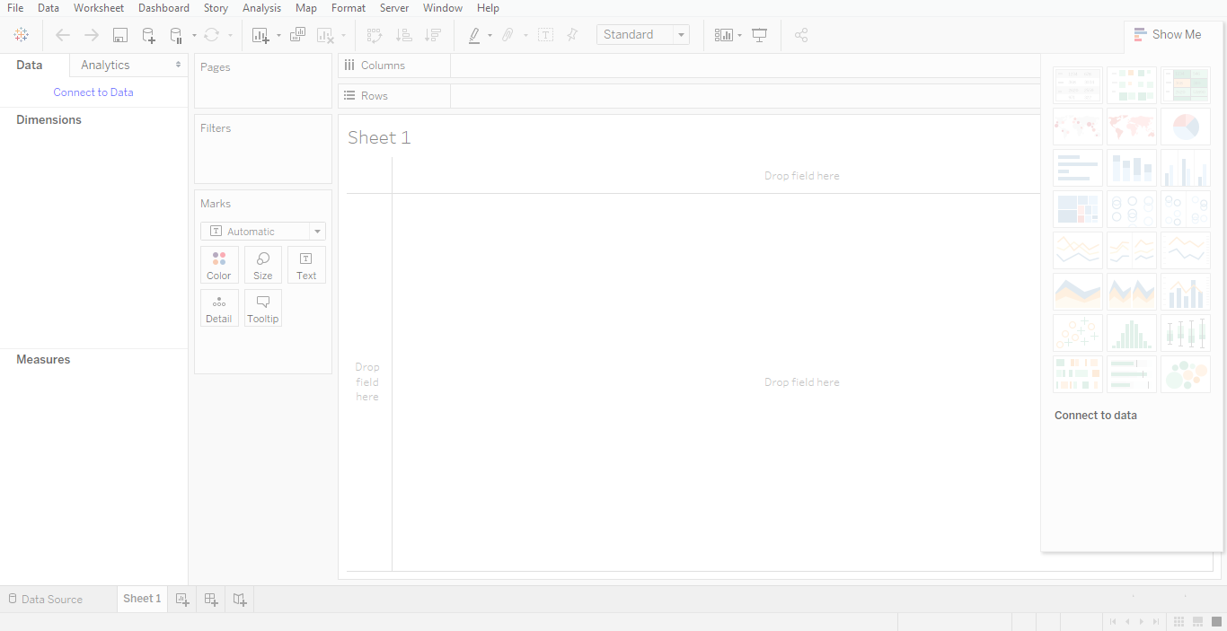](https://data-flair.training/blogs/wp-content/uploads/sites/2/2018/02/Screenshot-45.png)

*Tableau Navigation*

## Menu Commands in Tableau Navigation

On shutting the beginning window, you get the primary interface with all the accessible menu orders. They speak to the whole arrangement of tableau navigation highlights accessible in interfaces. Different areas of the menu have appeared in the accompanying outline. In addition, you can see a few subtle elements of every menu.

### a. File Menu

This menu in tableau navigation utilize to make another tableau exercise manual and therefore open existing exercise manuals from both the neighbourhood framework and tableau server. It seems like the imperative highlights in this menu are

**i. NEW –**is normally used to create new files, a shortcut for the same is “ctrl+N”

**ii. Open –**is used to open old/saved files, a shortcut for the same is “ctrl+O”

**iii. Close** – is used for close current book

**iv. Save –**is used to save file and the shortcut key is “ctrl+S”

**v. Save as –**is used to rename the same saved file

**vi. Export package –** option is utilized to make a bundled exercise manual, which will impart to different clients

**vii. Paste sheet –**this option is used to paste old sheets workbook into present sheet workbook

**viii. Workbook locale –**used for set reports language

**ix. Import workbook –**is used when we want to import data from another workbook

**x. Page setup –**used for setup of a page

**xi. Print and print pdf –**is used to print the workbook

[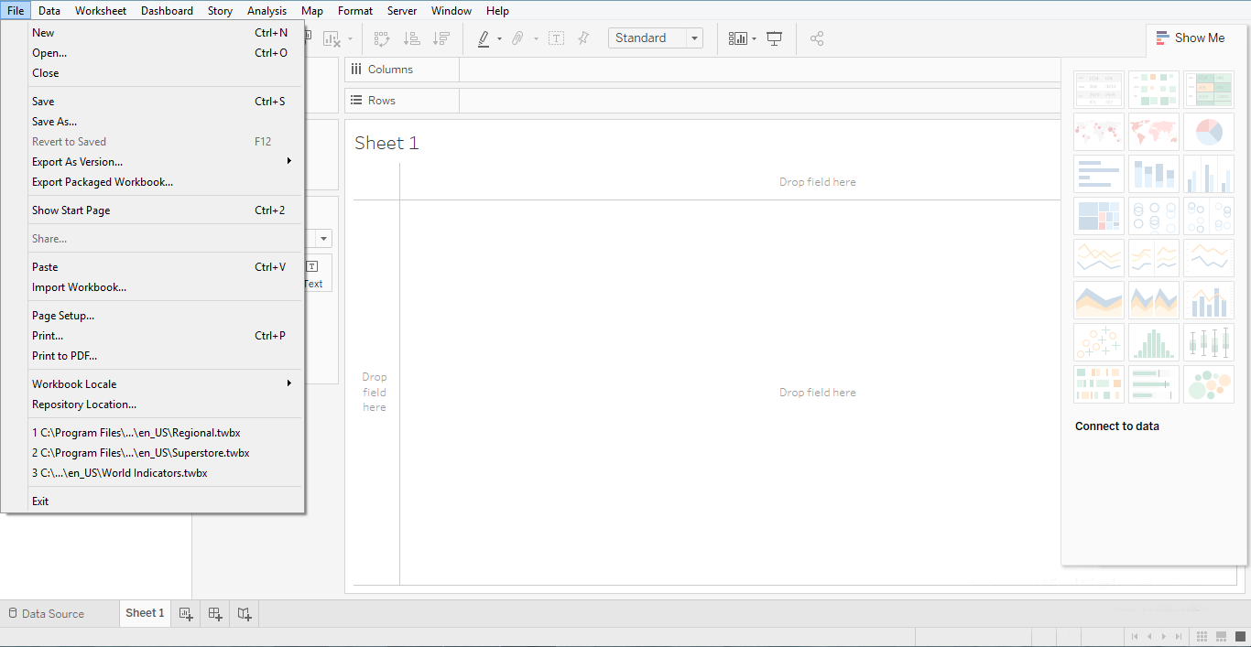](https://data-flair.training/blogs/wp-content/uploads/sites/2/2018/02/Screenshot-39.png)

*Tableau Navigation – File Menu*

### b. Data Menu

Same as above, this menu in tableau navigation, is utilize to make new information source to bring the information for examination and perception. It likewise enables you to supplant or overhaul the current information source.

The critical highlights in this menu are as per the following

**i. New data source –** permits to see every one of the kind of associations accessible and look over it

**ii. Refresh all extracts –**when we update the data extract source there is a need of refreshing of data

**iii. Edit relationships –**option defines the fields in more than one data source for linking

**iv. Replace data source –**choice characterizes the fields in more than one information hotspot for connection

[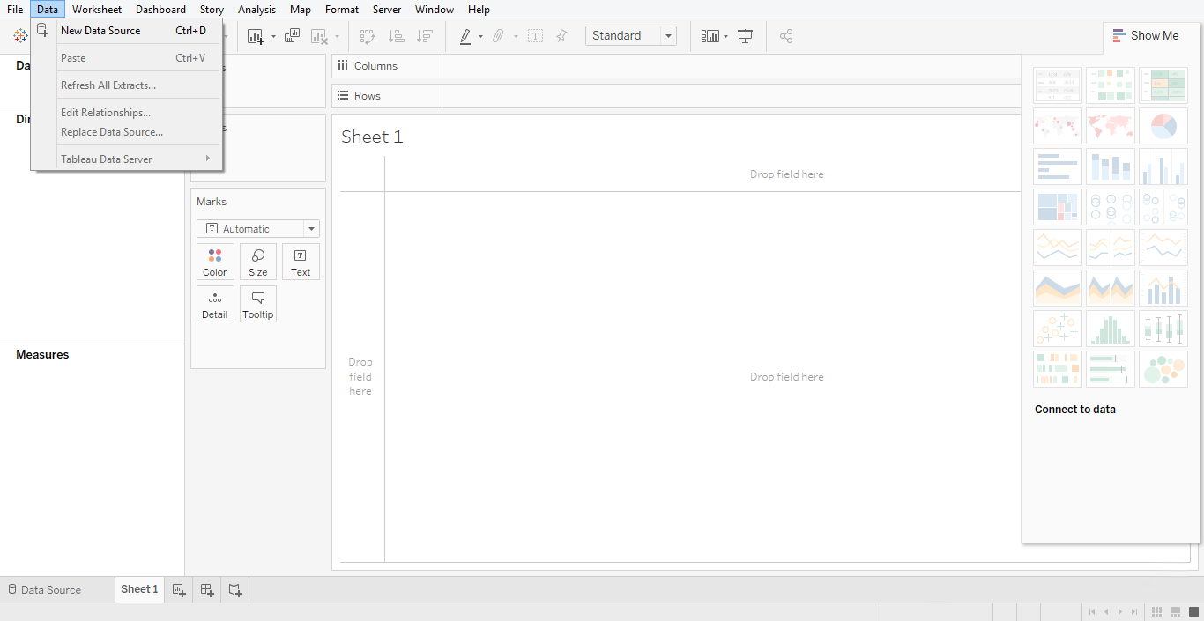](https://data-flair.training/blogs/wp-content/uploads/sites/2/2018/02/Screenshot-40.png)

*Tableau Navigation – Data Menu*

### c. Worksheet Menu

This menu in tableau navigation use to make another worksheet alongside different show highlights, for example, demonstrating the title and subtitles, and so on.

The imperative highlights in this menu are as per the following

**i. New worksheet –**The option used to take new worksheet

**ii. Show summary –**permits to see the synopsis of the information utilized as a part of the worksheet, for example, tally, etc

**iii. Run update –**option updates the worksheet data or filters used

**iv. Tooltip –**demonstrates the tooltip while floating above different information fields

**v. Show title, caption, card –**are used to show them on worksheet

[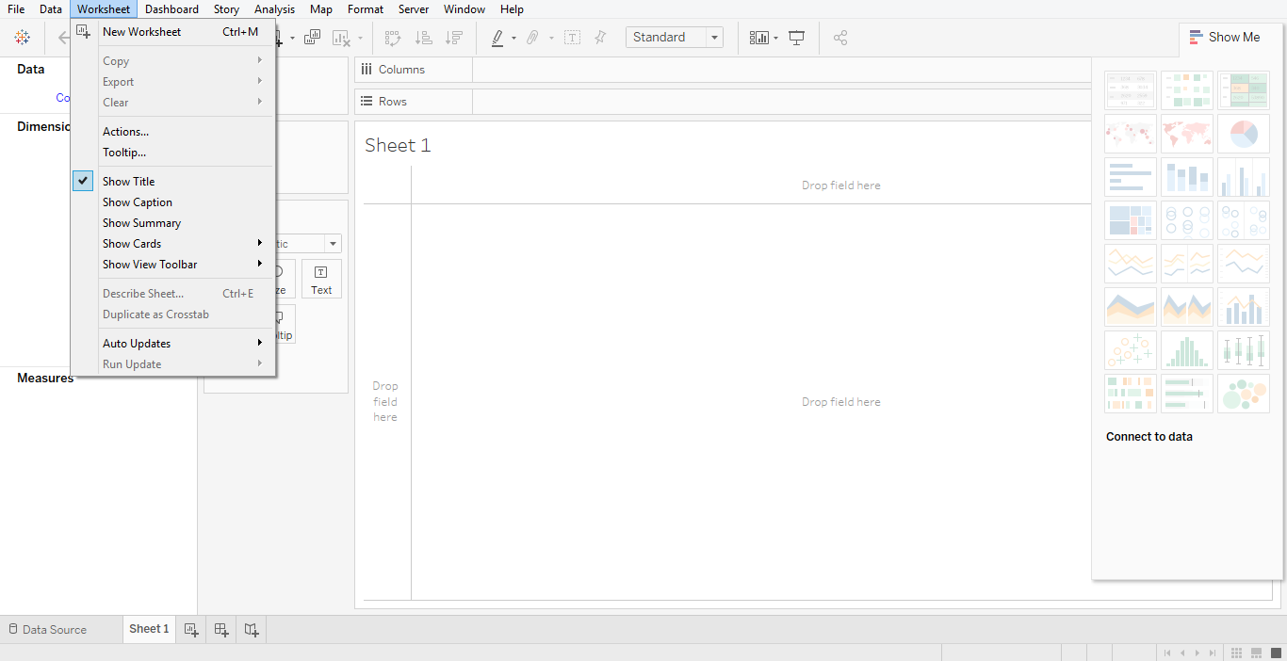](https://data-flair.training/blogs/wp-content/uploads/sites/2/2018/02/Screenshot-41.png)

*Tableau Navigation -Worksheet Menu*

### d. Dashboard Menu

This menu in tableau navigation, utilize to make another dashboard alongside different show highlights, for example, demonstrating the title and sending out the picture, and so forth.

The vital highlights in this menu are as per the following

**i. Format –**sets the format as far as hues and areas of the dashboard

**ii. Action –**used to link to URLs or external sheets

**iii. Export image –**option exports an image of the Dashboard

[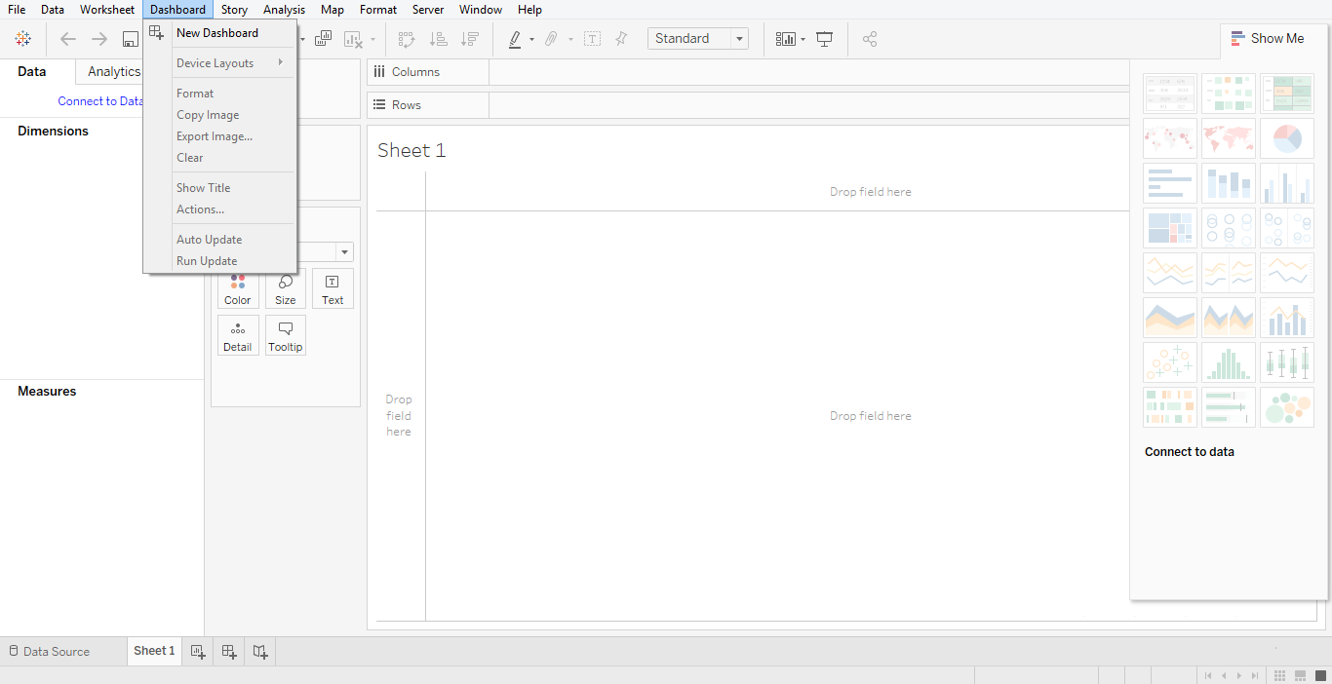](https://data-flair.training/blogs/wp-content/uploads/sites/2/2018/02/Screenshot-42.png)

*Tableau Navigation – Dashboard Menu*

**e. Story Menu**

This menu in tableau navigation, utilize to make another story which has numerous sheets or dashboards with related information.

The important features in this menu are as follows

**i. Format –**sets the layout in terms of colors and sections of the story

**ii. Run Update –**updates the story with the latest data from the source

**iii. Export Image –**option exports an image of the story

**iv. Show backward/show forward –**is used to look old worksheets

[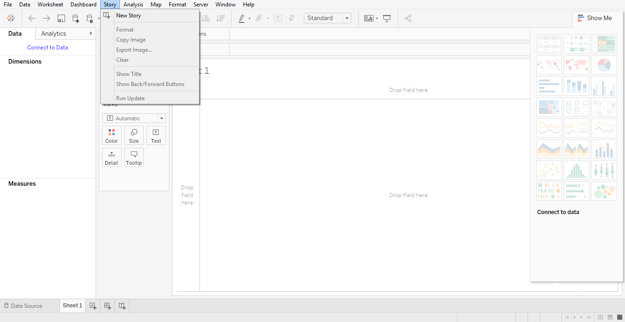](https://data-flair.training/blogs/wp-content/uploads/sites/2/2018/02/Screenshot-43.png)

*Tableau Navigation – Story menu*

*f.* **Analysis Menu**

This menu utilize for breaking down the information shown on the sheet. The scene gives numerous out-of-the-case highlights, for example, figuring the rate and playing out an estimate, and so forth.

The critical highlights in this menu are as per the following

**i. Forecast** – shows a forecast based on available data

**ii. Trend Lines** – shows the trend line for a series of data

**iii. Create Calculated Field –**option creates additional fields based on a certain calculation on the existing fields

**iv. Percentage –**of an option is used to find a percentage of any data

**v. Total** – function is used to find the total of any data

**vi. Special value** – is used to input special kind of value

[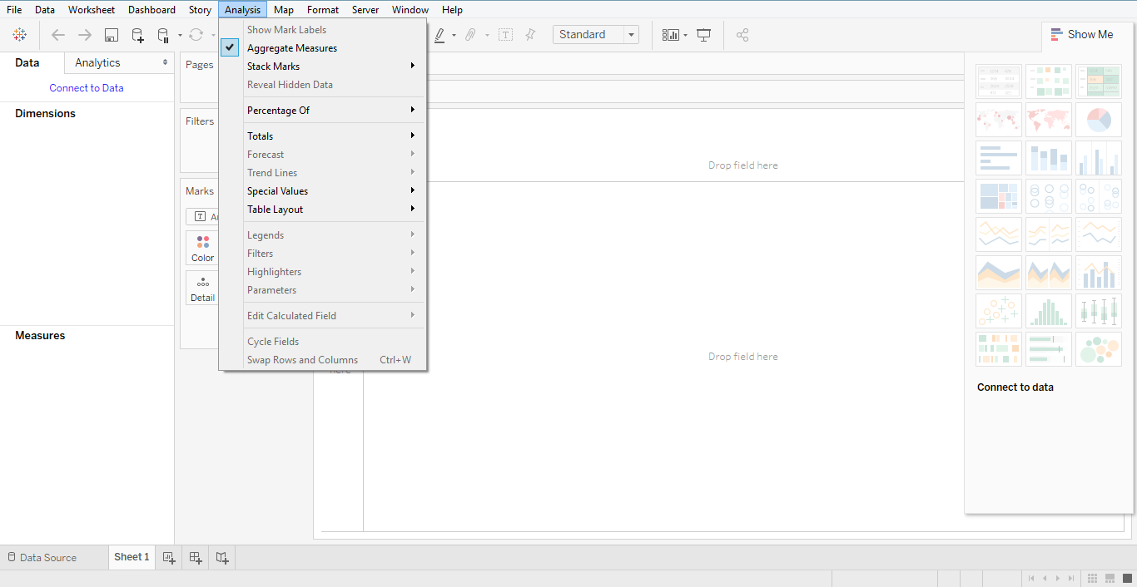](https://data-flair.training/blogs/wp-content/uploads/sites/2/2018/02/Screenshot-44.png)

*Tableau Navigation – Analysis menu*

### g. Map Menu

This menu in tableau navigation, utilize for building map sees in Tableau. You can also relegate geographic parts to fields in your information.

The important features in this menu are as follows

**i. Geocoding –**makes new geographic parts and appoints them to the geographic fields in your information

**ii. Map layers –**cover up and demonstrate outline, for example, road names, nation outskirts, and includes information layers

**iii. Background image** – helps setting images in the background

[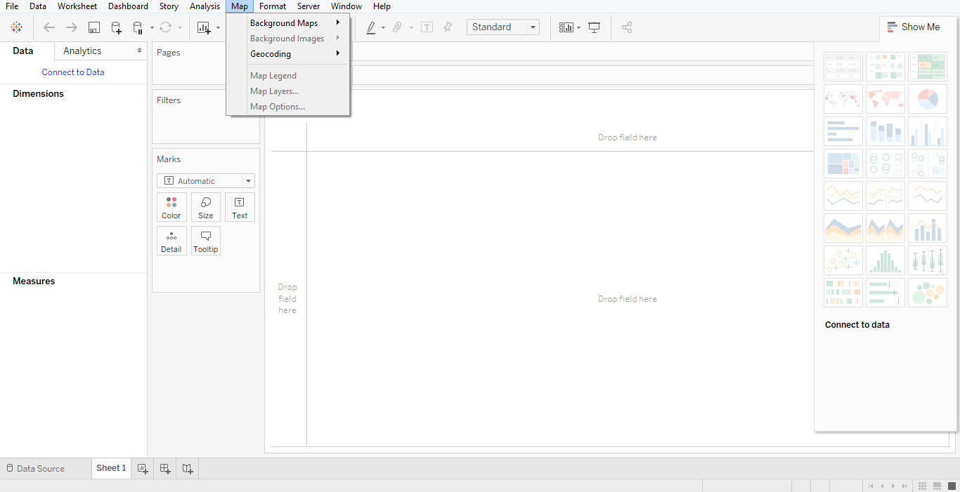](https://data-flair.training/blogs/wp-content/uploads/sites/2/2018/02/Screenshot-46.png)

*Tableau Navigation – Gap Menu*

### h. Format Menu

This menu utilize for applying the different organizing alternatives to upgrade the look and feel of the dashboards made. It gives highlights, for example, fringes, hues, an arrangement of content, and so forth.

The imperative highlights in this menu are as per the following

**i. Borders –**applies borders to the fields displayed in the report

**ii. Title & Caption –**assigns a title and caption to the reports

**iii. Cell Size –**customizes the size of the cells displaying the data

**iv. Workbook Theme** – applies a theme to the entire workbook

**v. Alignment** – is used for alignment of lines

**vi. Lines –**are used for types of lines

**vii. Font –**which kind of font you want to use

[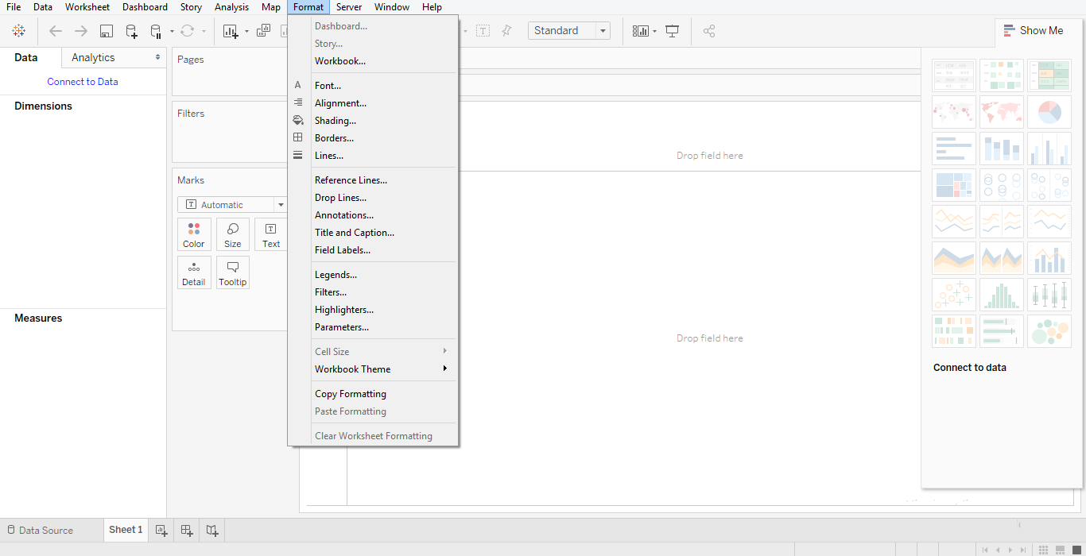](https://data-flair.training/blogs/wp-content/uploads/sites/2/2018/02/Screenshot-47.png)

*Tableau Navigation – Format Menu*

### i. Server Menu

Server Menu is for doing login to the Tableau server on the off chance that you approach, and distribute your outcomes to others to utilize. We use it to get the exercise manuals that others distribute.

The vital highlights in this menu are as per the following

**i. Publish Workbook –**publishes the workbook in the server to use by others

**ii. Publish Data Source –**publishes the source data used in the workbook

**iii. Create User Filters –**creates filters on the worksheet to apply by various users while accessing the report

[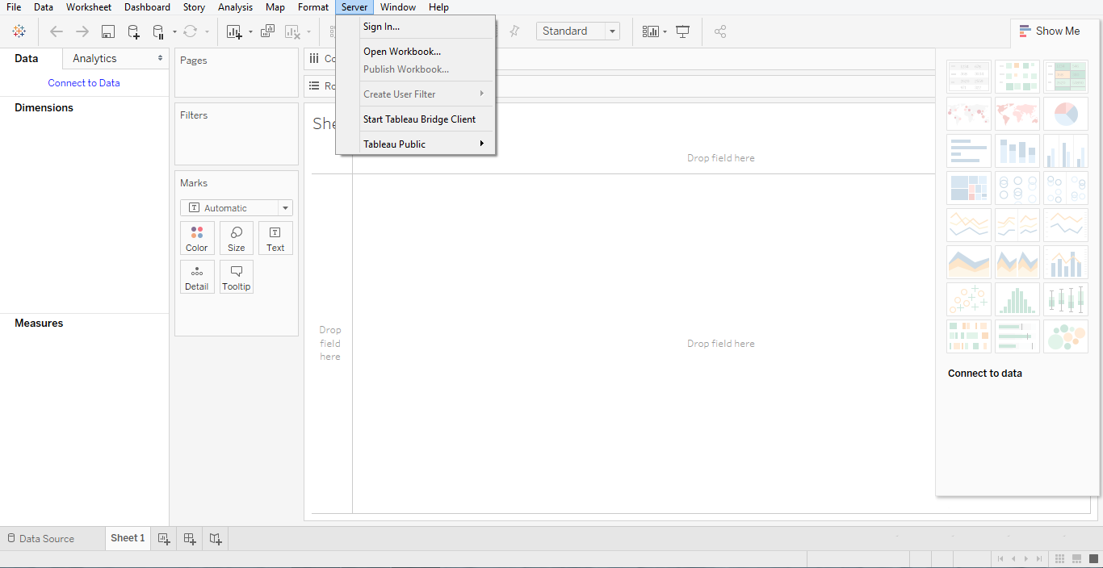](https://data-flair.training/blogs/wp-content/uploads/sites/2/2018/02/Screenshot-48.png)

**Tableau Data Types:**

### What are Data Types and Icons?

Data types characterize the data values into its definite type. Some data values are only text (eg. “SyntaxBoard”) so their data type will be a string as it only contains characters. While some data values have whole numbers (eg. 5550) and so their data type is an integer. If a data value is in the form of a date or time (eg. 22/02/2019 or 03:25:40) then the data type date/time is assigned to it. In a similar way, every data value will fall under a certain category of the data type. Tableau also has a set of data types based on which it characterizes every data value present in it as field values either from a live data connection or as a data extract from the data source.

There are primarily seven data types used in Tableau. Tableau automatically detects the data types of various fields as soon as new data gets uploaded from source to Tableau and assigns it to the fields. You can also modify these data types after uploading your data into Tableau by options available in the:

1. String values
2. Number (Integer) values
3. Date values
4. Date & Time values
5. Boolean values
6. Geographic values
7. Cluster or mixed values

In the Data pane of Tableau, each data type is denoted with a distinct icon shown in the table below. We can easily identify the data types of the fields in Tableau and also change them if we want. We will see how to change data types from different locations in Tableau in the next section. In this section, let us first make sure that we have a complete understanding of all the data types used in Tableau.[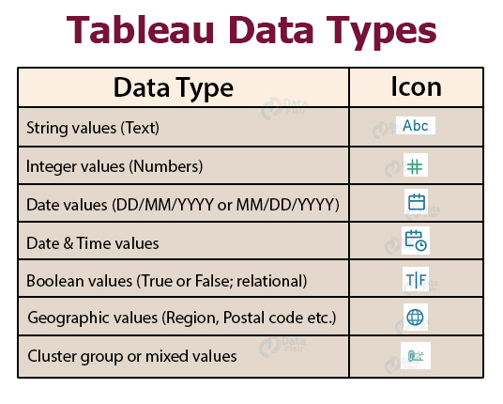](https://data-flair.training/blogs/wp-content/uploads/sites/2/2018/02/data-types-in-tableau.jpg)

## Data Types in Tableau

Let us understand each Tableau data type in detail here.

### 1. String Data Type

The string data type consists of zero or more characters meaning it is a text data type. A value is considered as a string when the characters are enclosed in a single or double quote (as known as single or double inverted commas). For instance, a string data value can be **“SYNTAXBOARD”** or **“SYNTAXBOARD Indore”** etc. You can also incorporate double inverted commas into a string for instance, **‘“Karthik says Hello” ’** which will show as**“Karthik says Hello”**.

The string data type is further divided into two categories; **Char** and **Varchar**.

* **Char string type:** The values of this data type have a fixed length. Memory corresponding to this fixed length is allocated to char string type values in Tableau. If you try to enter a string value with a length greater than the fixed length, then the system is going to show an error. This data type generally stores alphanumeric data values.
* **Varchar string type:** Varchar string type stands for variable character length where the length of the characters to be entered in a string is not fixed or predefined. You can enter as many characters as you want without having any memory allocation restrictions. This string type can also have alphanumeric data values.

### 2. Numeric Data Type

The numeric data type values can be either an integer type or floating type. Most fields having numeric data type are of integer type because with float values, users face difficulty in accumulating the decimal point after a certain limit. However, float values can also be used easily in calculations after rounding them up to corresponding integers. A function known as Round function is used for rounding up float values.

### 3. Date and Time Data Types

In Tableau, all formats of date and time are accepted such as dd-mm-yy, dd-mm-yyyy or mm-dd-yyyy, etc. Some fields can only contain a date value or a date can exist along with the time (like a timestamp). The time data values can be decade, year, quarter, month, day, hour, minutes, seconds, etc. Also, if you wish to add a date value in the form of string characters, add a # sign before it (for instance, #22 January 2020). Tableau registers date and time values under two data types which are Date data type and Date & Time data value.

### 4. Boolean Data Type

The boolean data type values are a result of relational calculations. Therefore, True and False boolean values are known as logical values. Sometimes, the result of a relational calculation is unknown and obscure. Such values are shown as Null values.

### 5. Geographic Data Type

The geographic data values are all that are used in a map. Values such as country name, state name, city, region, postal codes, etc. belong to the geographic data type. The fields of this data type are denoted by a globe icon.

### 6. Cluster or Mixed Data Type

Sometimes a field might not consist of a single data type and rather have a mixture of data types. This is also known as cluster group values or mixed data values. In such scenarios, either you can manually handle such fields by segregating values belonging to different data types into the column or let Tableau handle it.

### Changing Data Types in Tableau

Ideally, Tableau detects and assigns respective data types to all the existing fields in a data set during fresh data upload. However, you can make changes in the data types at many stages while working in Tableau. Three of which are shown below:

#### **1. Changing data type of a field in Data Source page**

To change the data type of a field from the Data Source page, click on the data type icon of that field. A drop-down list will appear from where you can select a new data type and assign it to the values of that field.

[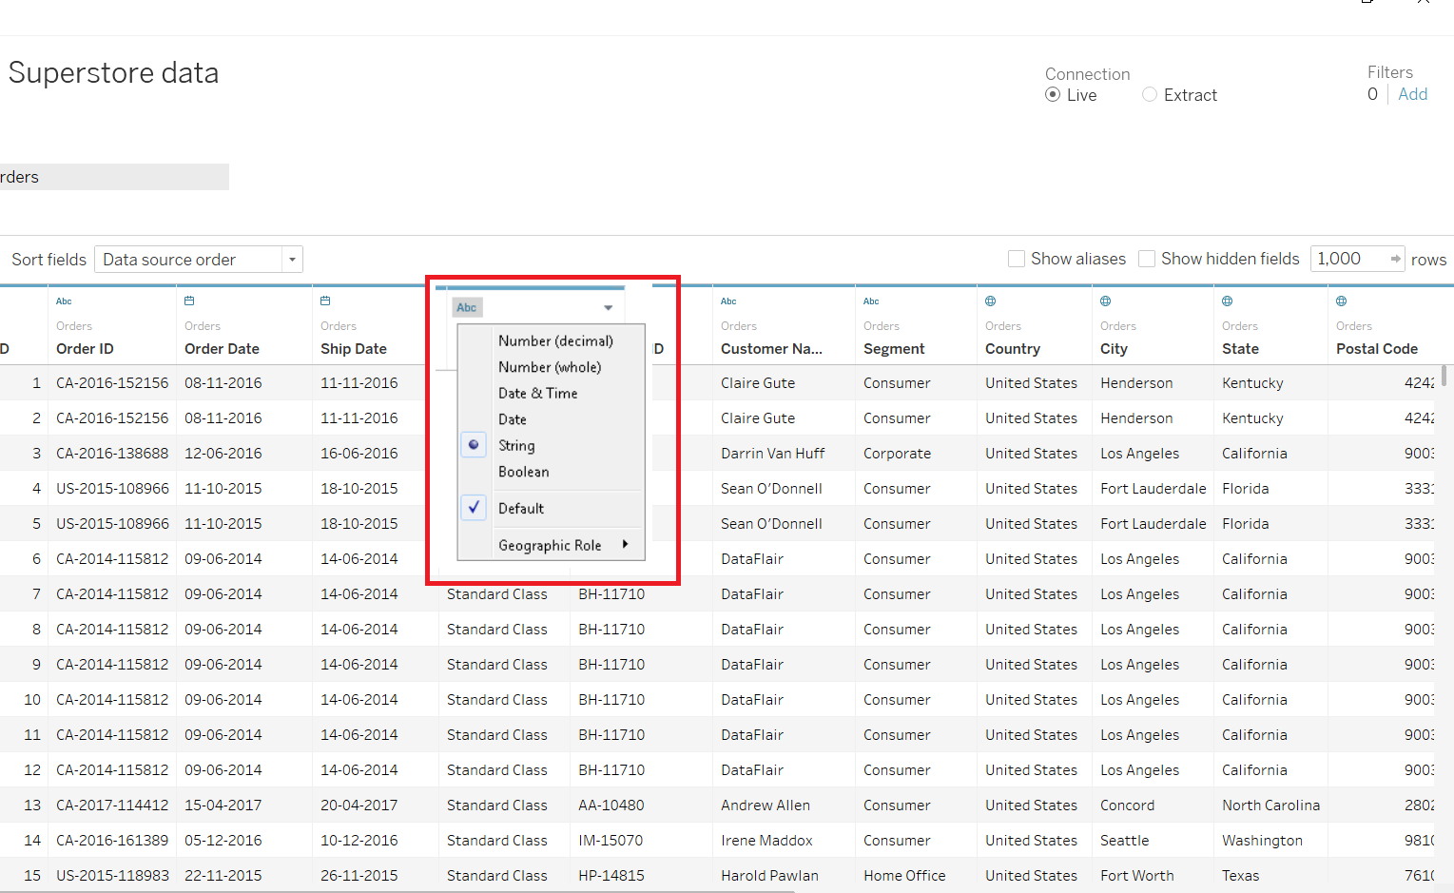](https://data-flair.training/blogs/wp-content/uploads/sites/2/2020/02/change-data-type-in-data-source-page.png)

#### **2. Changing data type of a field from Data pane**

Once a data set gets uploaded in Tableau, the underlying data fields are shown in the **Data** pane of a Tableau [worksheet](https://help.tableau.com/current/pro/desktop/en-us/environ_workbooksandsheets.htm). We can also change the data type of a field from here. To do this, click on the data type icon of a field and select a new data type for the values of that field from the list that opens.

[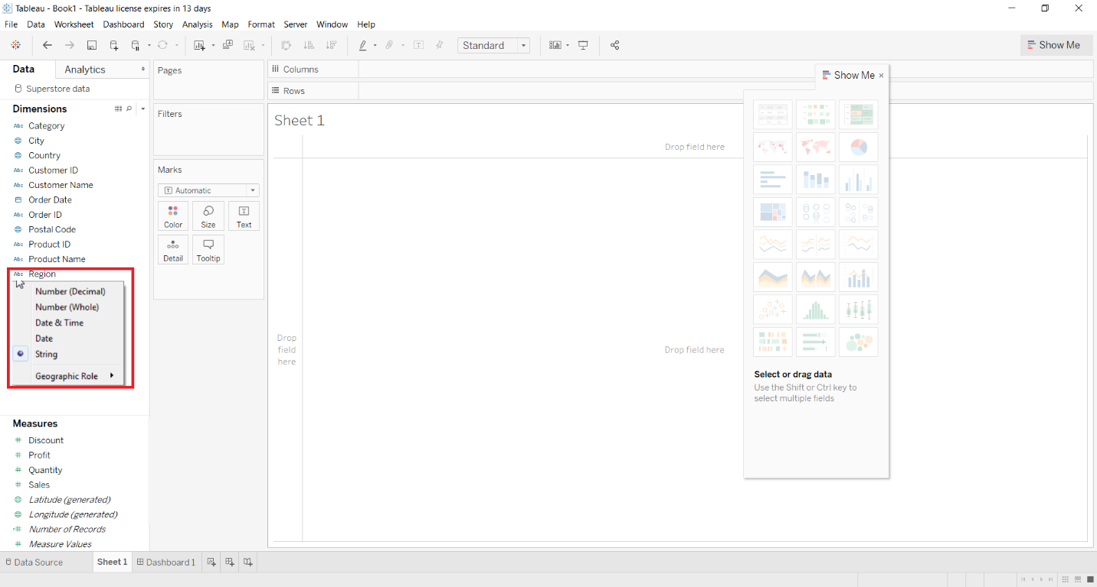](https://data-flair.training/blogs/wp-content/uploads/sites/2/2020/02/Change-data-type-in-data-pane.png)

#### **3. Changing the data type of a field in the View**

Another way to change the default data type of a field is from the View. Here, right-click on the field and then select **Change Data Type** from the drop-down list. This will further open a list of data types from where you can select the data type of your choice as shown in the image below.

[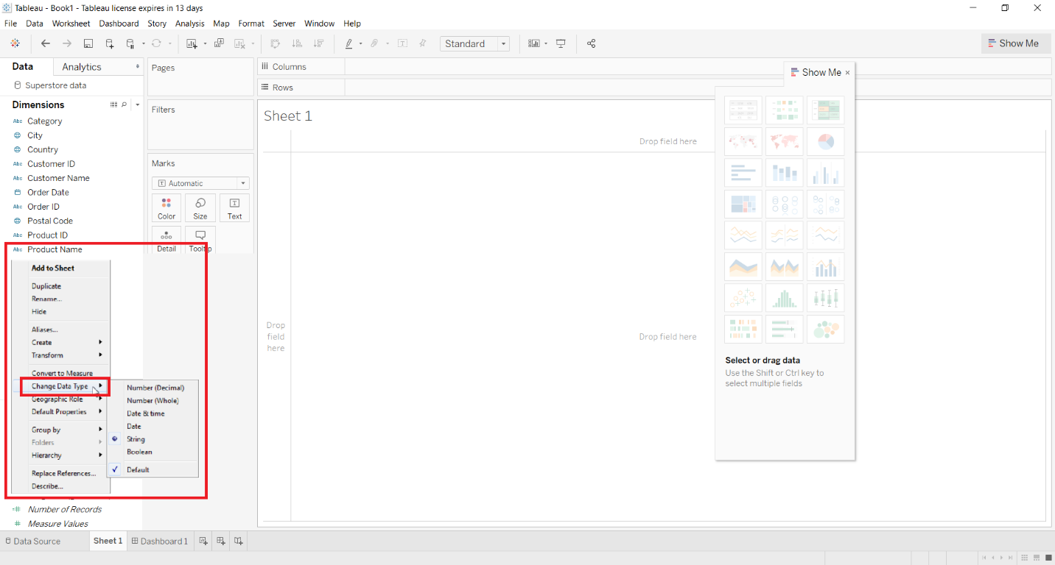](https://data-flair.training/blogs/wp-content/uploads/sites/2/2020/02/Change-data-type-in-view.png)

### Mixed Data Types from Files in Tableau

Often times when we import data from files like MS Excel, Access, CSV, etc. the columns have mixed data types. Data values with mixed data types can have numbers and texts together or dates and numbers. Usually, whenever new data gets uploaded in Tableau, it maps the appropriate data type for the values in each column and assigns it to the column. It is a simple process when a column contains the values of a single data type. In that case, a typical date or text column is a dimension field and a numeric column is a measure field.

But when a column has more than one data type in its values, the mapping rules are a little specific for each file type.

* The data type in Excel is decided by the data type (date, text, number, boolean) of the first 10,000 rows.
* In a CSV file, the data type id decided by the data type of the first 1024 rows.

**Tableau Operators:**

Types of Operators in tableau: Arithmetic Operators, Relational Operators, Logical Operators with examples.

An image which is utilized to impart the compiler to play out certain scientific or consistent controls is an Operator. Various administrators are offered by Tableau to make recipes and computed fields.

## Types of Tableau Operators

There are 3 basic operators in tableau:

* Arithmetic Tableau Operators
* Relational Tableau Operators
* Logical Tableau Operators

a. Arithmetic Operators

The Arithmetic administrators can be utilized to make articulations on numbers and date information compose segments.

* Addition       –       +
* Subtraction  –       –
* Multiply       –       *
* Divide         –        /
* Modulation  –        %
* Power         –        ^

**Note: The Arithmetic Tableau Operators can be used in any clause of a SQL statement, except the from clause.**

### b. Relational Operators

A comparison operator is a binary operator that takes two operands whose values are being compared. Comparison operators are used in conditional statements, especially in loops, where the result of the comparison decides whether execution should proceed. They form the key to program flow control, known as conditional processing.

* Equality Operator                         –      =
* Not Equality Operator                   –     < >,  !=, ^=
* Greater Than Operator                  –     >
* Less Than Operator                       –     <
* Greater Than Equal to Operator      –     >=
* Less Than Equal to Operator          –      <=

[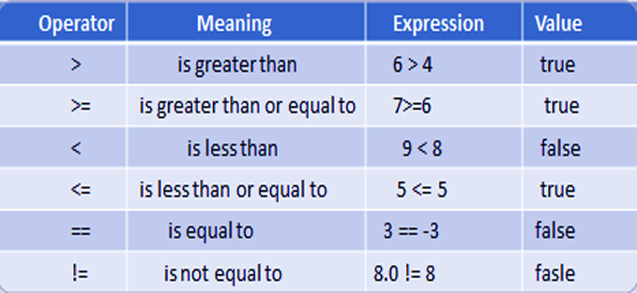](https://data-flair.training/blogs/wp-content/uploads/sites/2/2018/03/Relational.png)

*Relational Tableau Operators*

**Example:**

* Select Ename, Sal, Job From Emp Where Job = ’SALES MANAGER’;
* Select Ename, Hiredate, Deptno, Sal From Emp where Deptno < > 10;
* Select Empno, Ename, Sal From Emp where Sal >= 3000;
* Select Ename name, Sal basic, Sal * 12 Annual From Emp where sal * 12 > 60000;

### c. Logical Operators

Logical operators contain only three commands.  
a. Logical conjunction operator “AND”  
b. Logical disjunction operator “ OR”  
c. Logical negation operator “NOT”

#### **i. Conditions satisfy “AND” Operators**

1. It Returns TRUE if both or all component conditions are TRUE.
2. It Returns FALSE if either is FALSE, else returns unknown.

[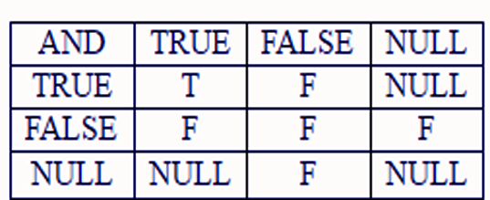](https://data-flair.training/blogs/wp-content/uploads/sites/2/2018/03/Screenshot-200.png)

*Logical Operators – AND operators*

#### **ii. Conditions satisfy “OR” Operators**

1. It Returns TRUE if either of the component conditions is TRUE.
2. It Returns FALSE if both are FALSE, else returns unknown.

[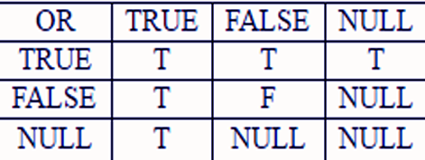](https://data-flair.training/blogs/wp-content/uploads/sites/2/2018/03/Screenshot-201.png)

*Logical Operators – OR operators*

#### **iii. Conditions satisfy “NOT” Operators**

1. It Returns TRUE if the following condition is FALSE.
2. It Returns FALSE if the following condition is TRUE.
3. If the condition is unknown, it returns unknown.

[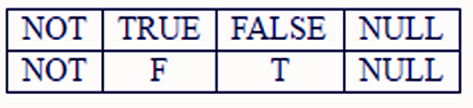](https://data-flair.training/blogs/wp-content/uploads/sites/2/2018/03/Screenshot-202.png)

**Tableau Design Flow:**

### a. Connect to Data Source

Scene interfaces with every single famous datum sources. It has inbuilt connectors which deal with building up the association, once the associated parameters are provided. Be it basic content documents, social sources, SQL sources or cloud information bases, Tableau associates with about each datum source.

### b. Building Data Views

In the wake of interfacing with an information source, you get all the section and information accessible in the Tableau condition. You order them as measurements and measures and make any progressive system required. Utilizing these you fabricate sees, which are customarily known as Reports. The scene gives simple drag and drops highlight to assemble sees.

### c. Enhance the Data Views

The perspectives made above should improve further by the utilization of channels, totals, marking of tomahawks, designing of hues and outskirts, and so forth.

### d. Create Worksheets

Create different worksheets to create different views on the same or different data.

### e. Create and Organize the Dashboard

Tableau dashboards contain various worksheets which are connected. Subsequently, the activity in any of the worksheet can change the outcome in the dashboard appropriately.

### f. Create a Story

A story is a sheet that contains a succession of tableau worksheets or dashboards that cooperate to pass on data. You can make stories to indicate how realities associate, giving setting, show how choices identify with results or essentially put forth a convincing defense.

**Creating a Dashboard:**

A dashboard is a collection of different kinds of visualizations or views that we create on Tableau. We can bring together different elements of multiple worksheets and put them on a single dashboard. The dashboard option enables us to import and add charts and graphs from worksheets to create a dashboard. On a dashboard, we can place relevant charts and graphs in one view and analyze them for better insights.

**1. Open a new dashboard**

You can open a dashboard window either from the **Dashboard** option given on the menu bar or from the Dashboard icon highlighted in red on the bottom bar.

[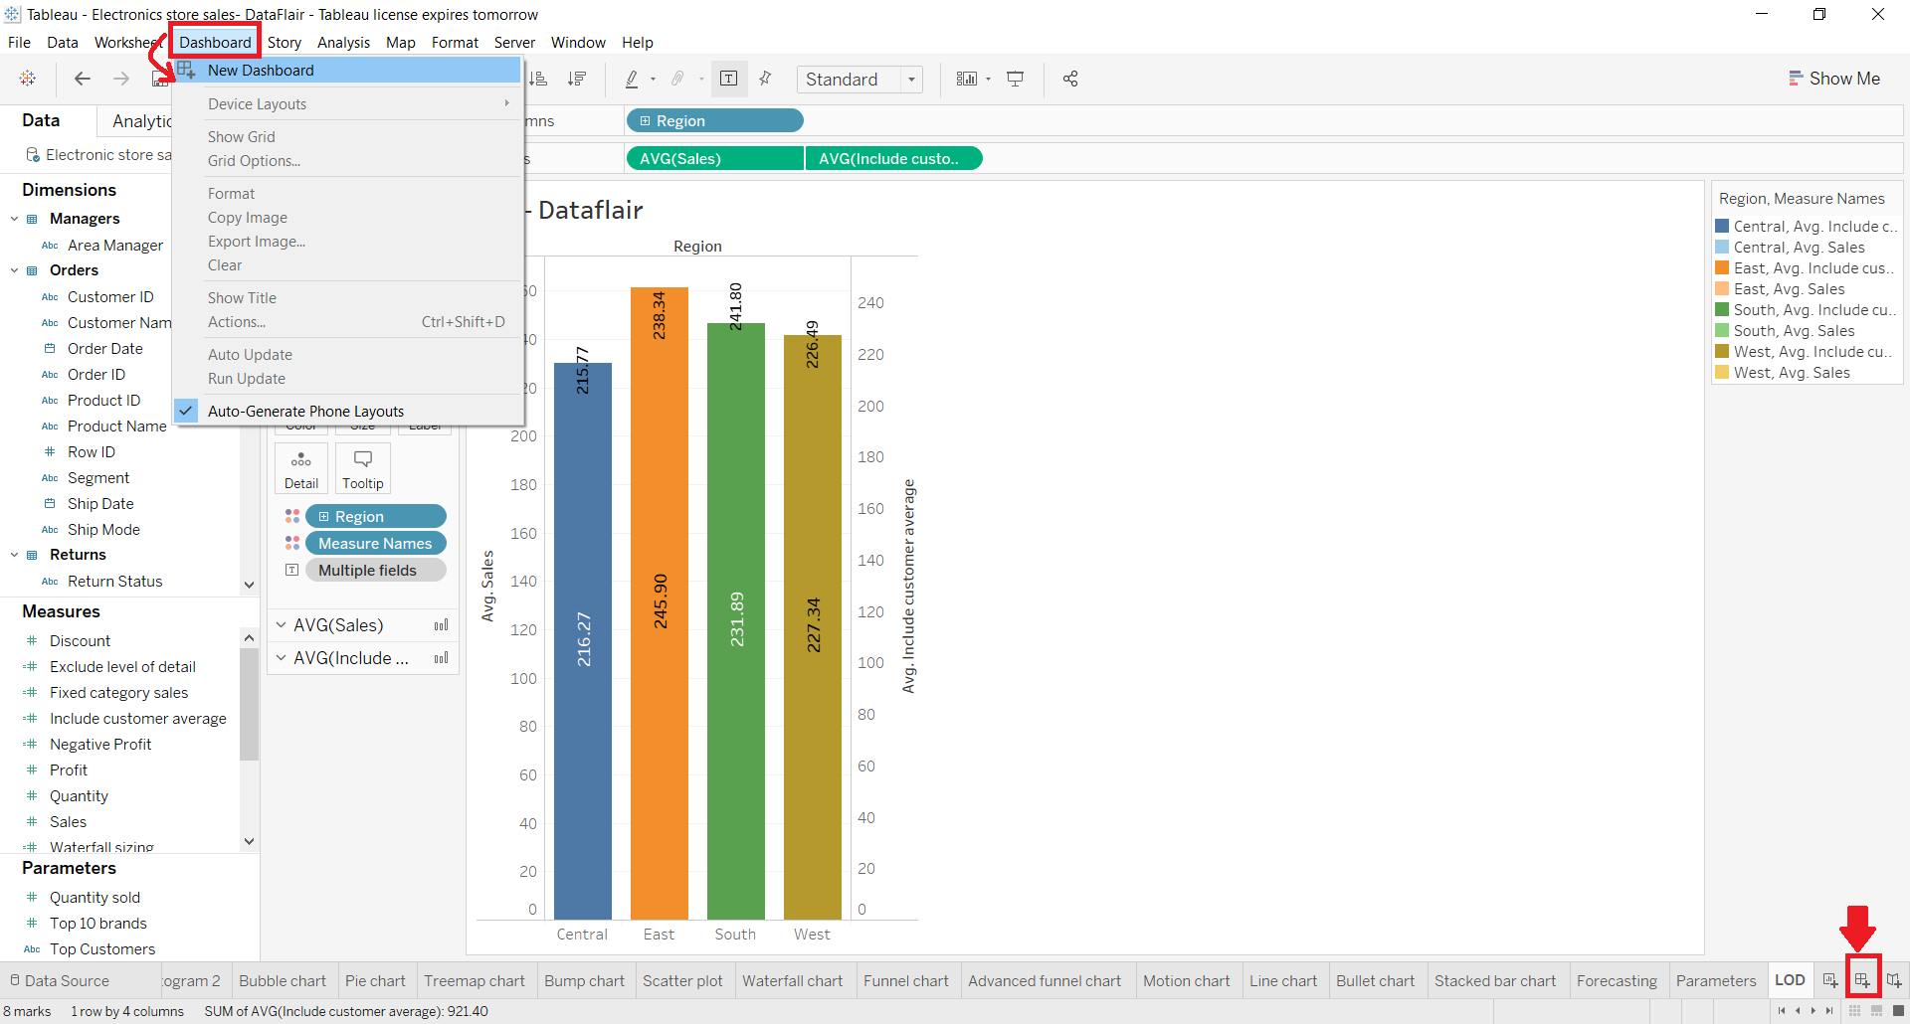](https://data-flair.training/blogs/wp-content/uploads/sites/2/2019/11/new-dashobard-option.png)

Selecting the **New Dashboard** option or clicking on the Dashboard icon will open a new window named **Dashboard 1**. You change the name of the dashboard as per your liking.

[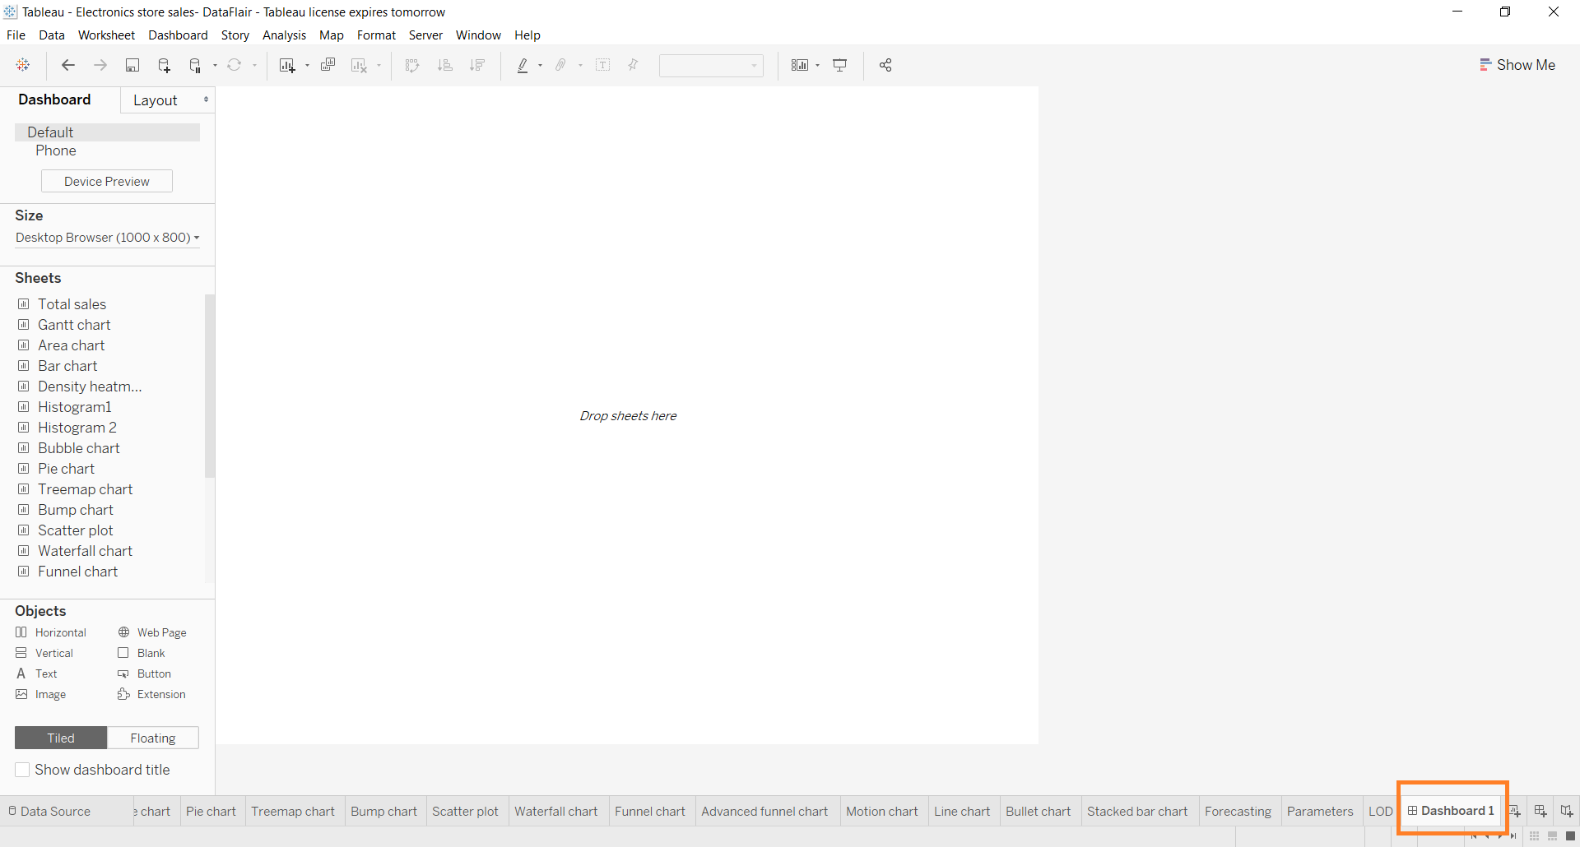](https://data-flair.training/blogs/wp-content/uploads/sites/2/2019/11/new-dashboard-window.png)

**2. Dashboard pane**

In the window where we can create our dashboard, we get a lot of tabs and options related to dashboarding. On the left, we have a Dashboard pane which shows the dashboard size, list of available sheets in a workbook, objects, etc.

[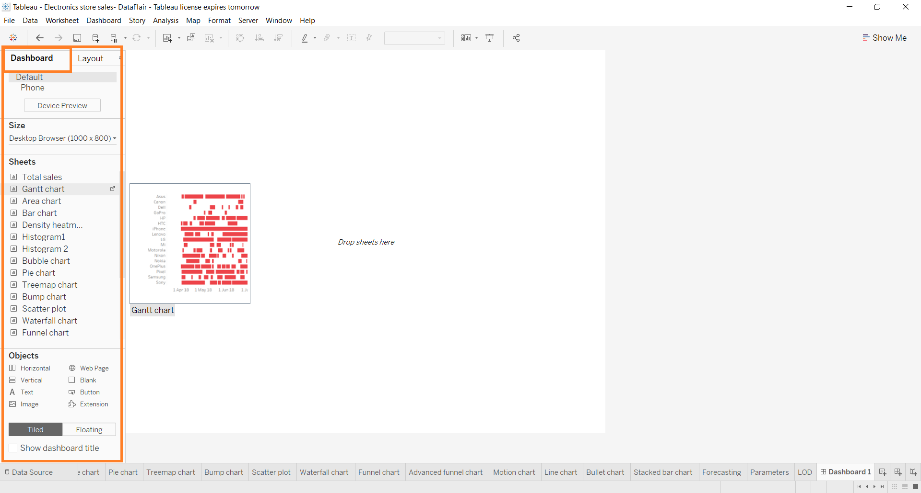](https://data-flair.training/blogs/wp-content/uploads/sites/2/2019/11/Dashboard-Pane.png)

From the Dashboard tab, we can set the size of our dashboard. We can enter custom dimensions like the width and height of the dashboard as per our requirements.

[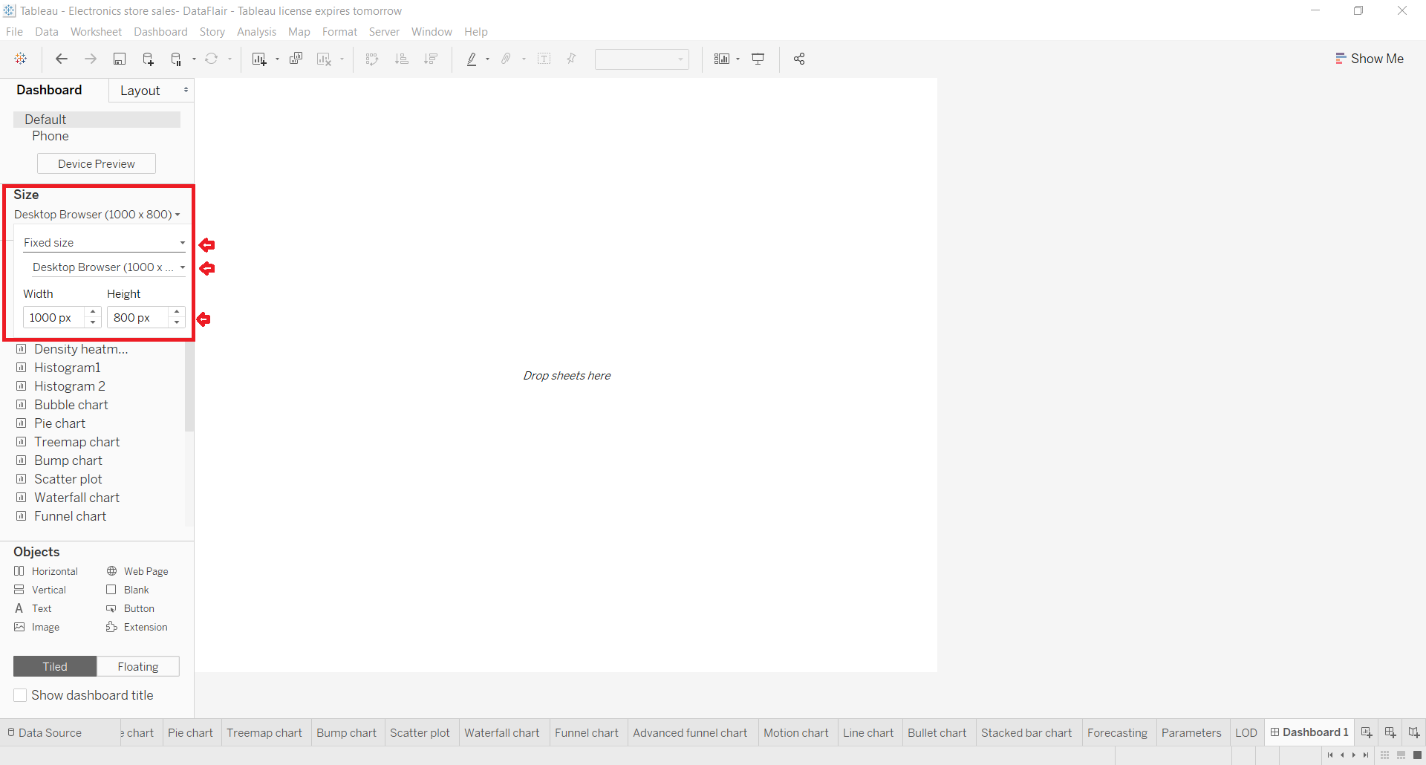](https://data-flair.training/blogs/wp-content/uploads/sites/2/2019/11/set-size-in-dashboard-tab.png)

Or, you can select from a list of available fixed dashboard sizes as shown in the screenshot below.

[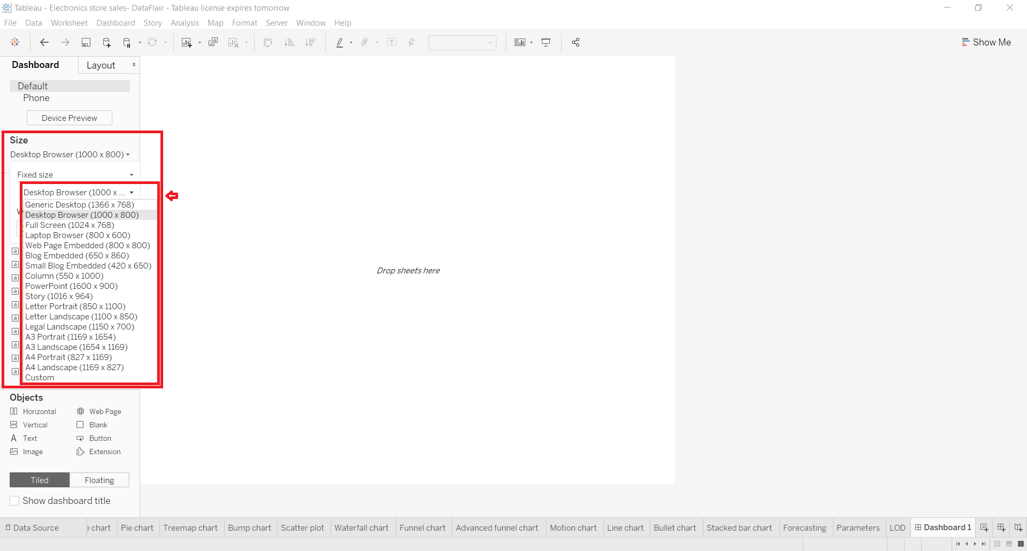](https://data-flair.training/blogs/wp-content/uploads/sites/2/2019/11/dashboard-sizes.png)

**3. Layout pane**

Right next to the **Dashboard** pane is the **Layout** pane where we can enhance the appearance and layout of the dashboard by setting the position, size, border, background, and paddings.

[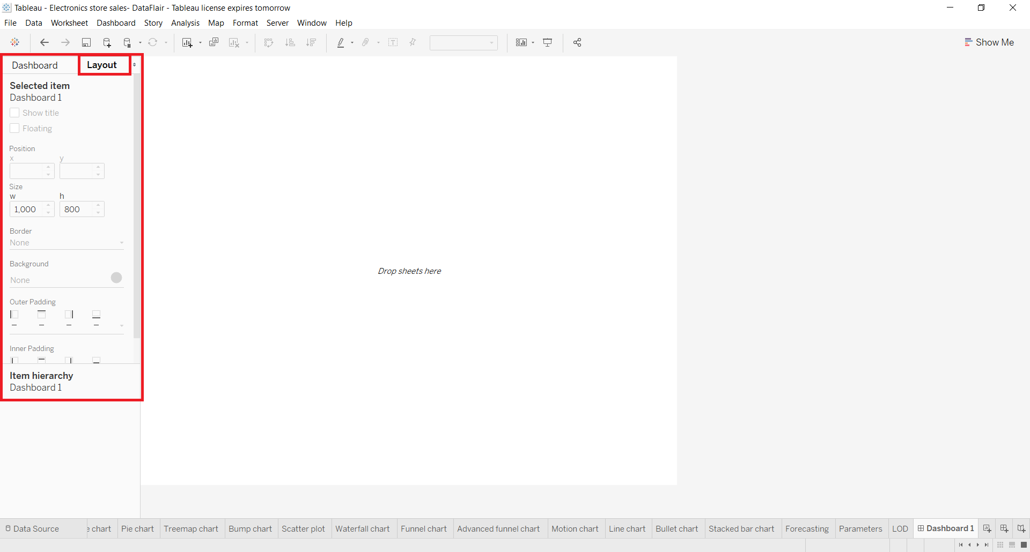](https://data-flair.training/blogs/wp-content/uploads/sites/2/2019/11/Layout-Pane.png)

**4. Adding a sheet**

Now, we’ll add a sheet onto our empty dashboard. To add a sheet, drag and drop a sheet from the **Sheets** column present in the **Dashboard** tab. It will display all the visualizations we have on that sheet on our dashboard. If you wish to change or adjust the size and place of the visual/chart/graph, click on the **graph** then click on the small **downward arrow** given at the right. A drop-down list appears having the option **Floating**, select it. This will unfix your chart from one position so that you can adjust it as per your liking.

[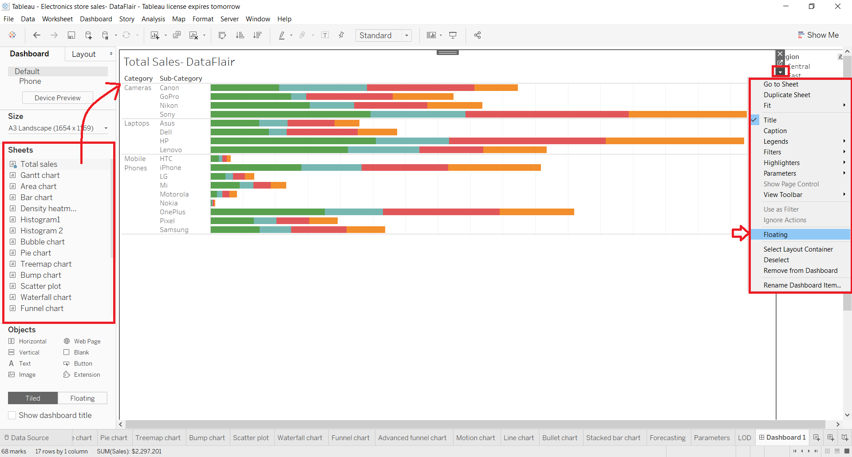](https://data-flair.training/blogs/wp-content/uploads/sites/2/2019/11/adding-a-sheet.png)

Have a look at the picture below to see how you can drag a sheet or visual around on the dashboard and adjust its size.

[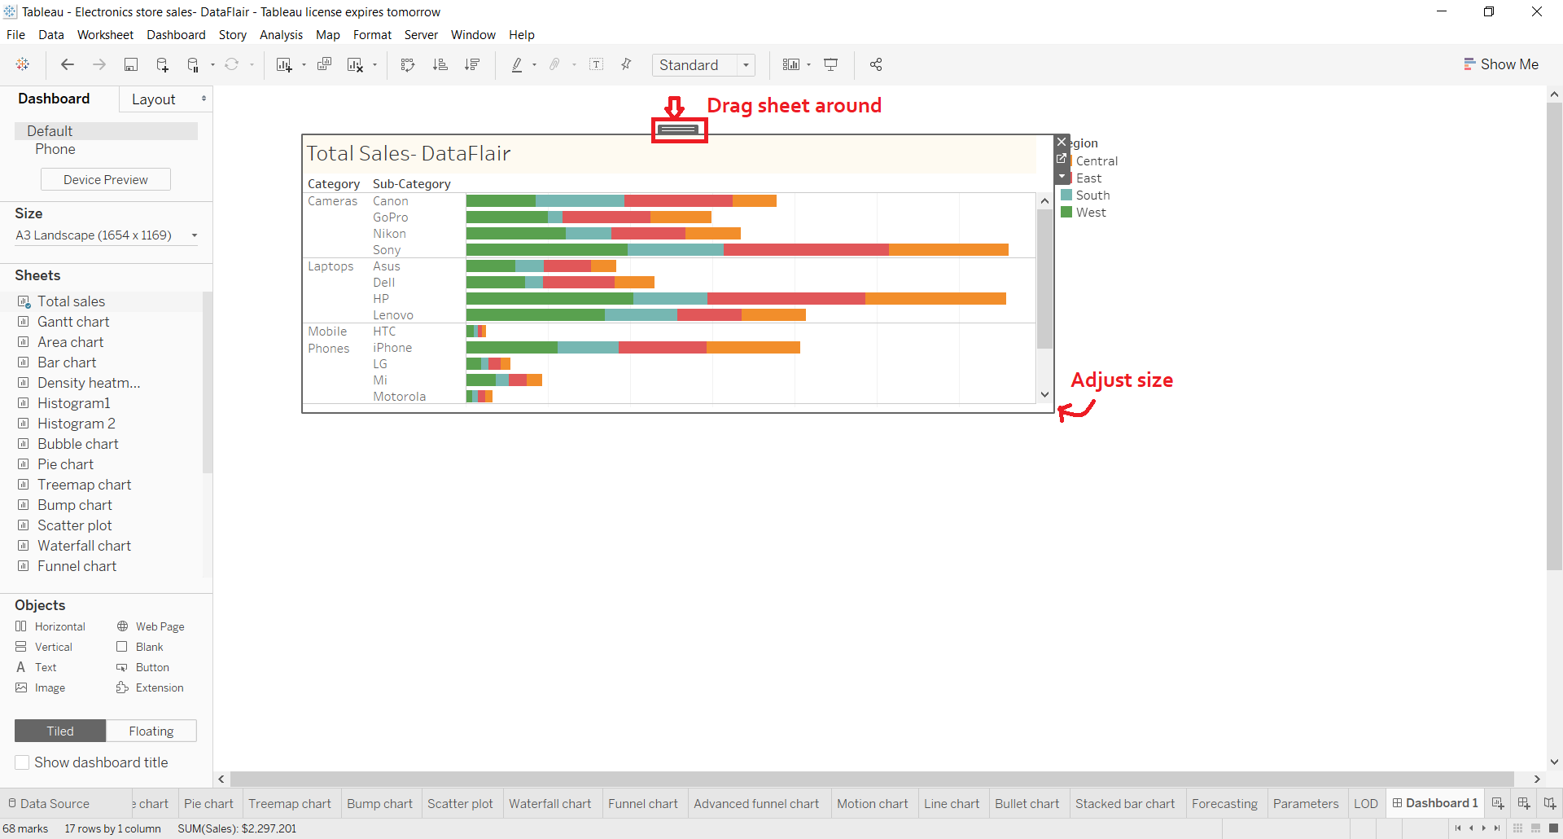](https://data-flair.training/blogs/wp-content/uploads/sites/2/2019/11/drag-sheet-adjust-size.png)

**5. Adding more sheets**

In a similar way, we can add as many sheets as we require and arrange them on the dashboard properly.

[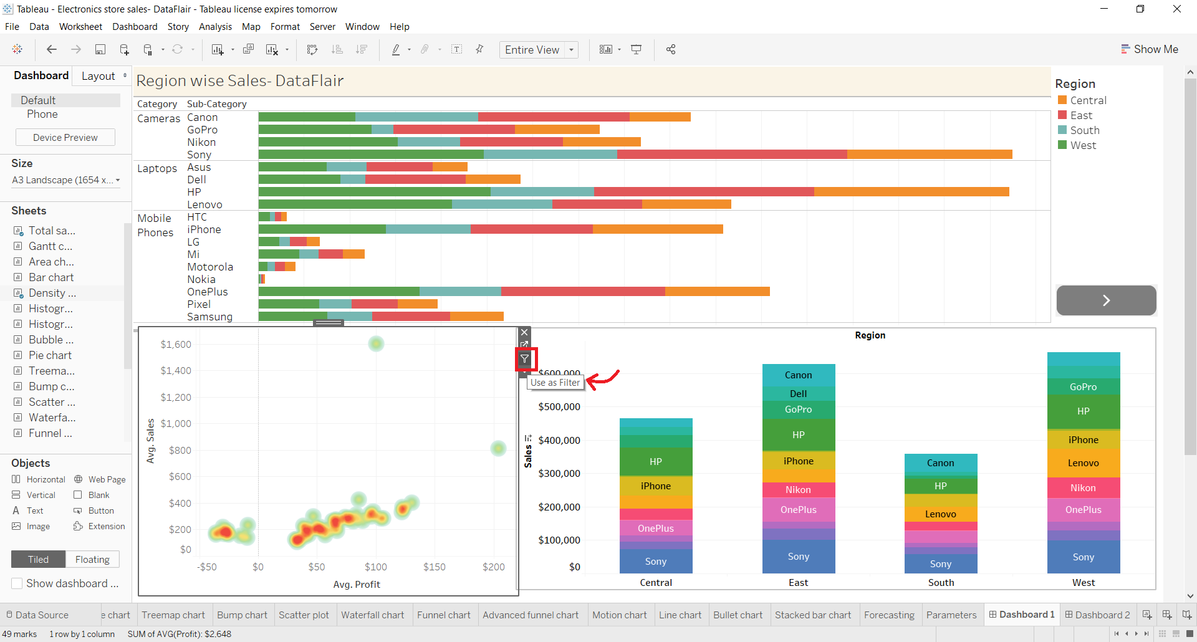](https://data-flair.training/blogs/wp-content/uploads/sites/2/2019/11/adding-more-sheets.png)

Also, you can apply the filter or selections on one graph and treat it like a filter for all the other visuals on the dashboard. To add a filter to a dashboard in Tableau, select **Use as Filter**option given on the right of every visual.

[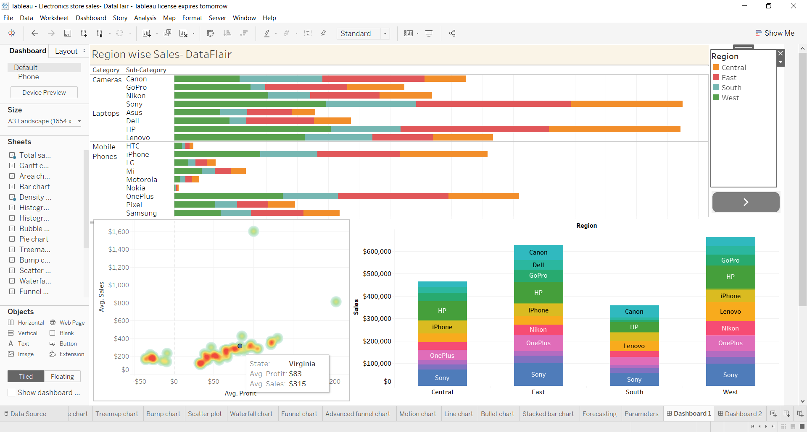](https://data-flair.training/blogs/wp-content/uploads/sites/2/2019/11/use-as-filter-option-1.png)

Then on the selected visual, we make selections. For instance, we select the data point corresponding to New Jersey in the heat map shown below. As soon as we select it, all the rest of the graphs and charts change their information and make it relevant to New Jersey. Notice in the **Region** section, the only region left is East which is where New Jersey is located.

[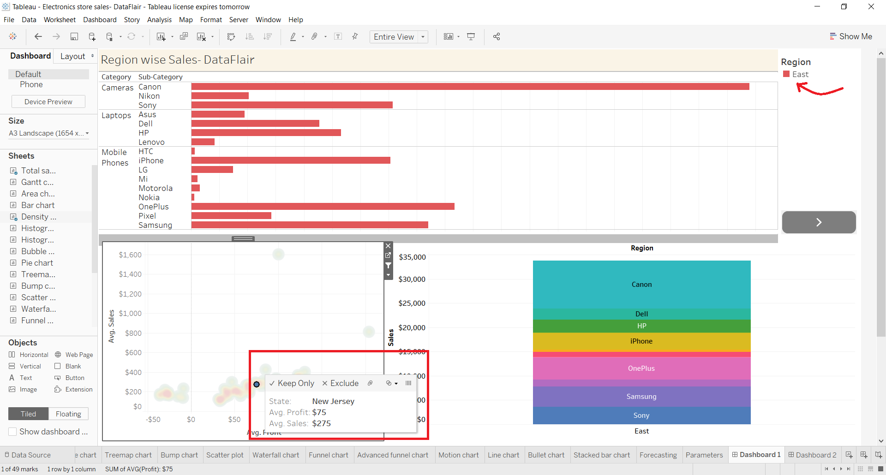](https://data-flair.training/blogs/wp-content/uploads/sites/2/2019/11/Heat-map-region-section.png)

**6. Adding objects**

Another set of tools that we get to make our dashboard more interactive and dynamic is in the **Objects** section. We can add a wide variety of objects such as a web page, button, text box, extension, etc.

[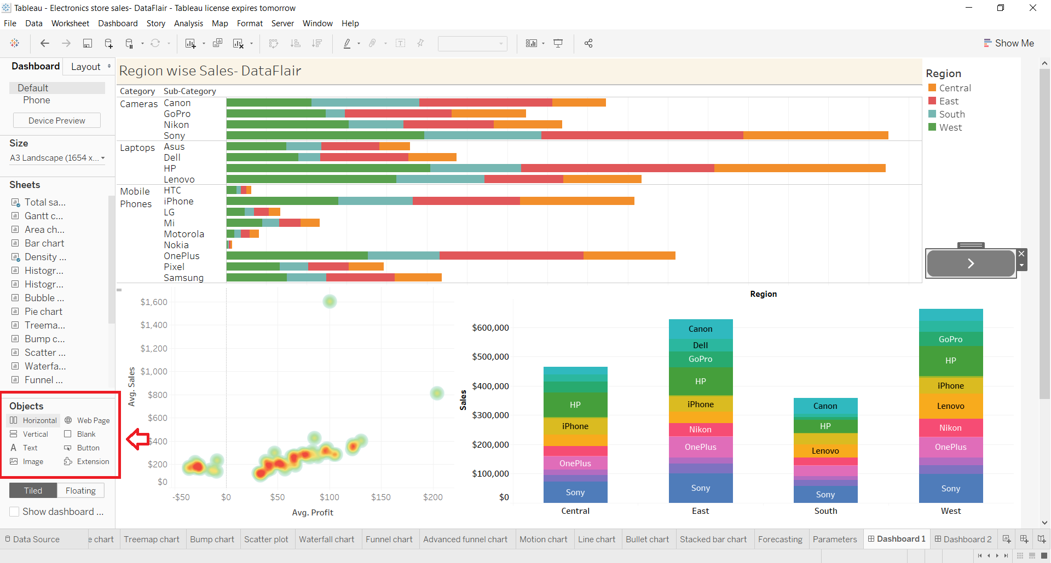](https://data-flair.training/blogs/wp-content/uploads/sites/2/2019/11/adding-objects.png)

From the objects pane, we can add a button and also select the action of that button, that is, what that button should do when you click on it. Select the **Edit Button** option to explore the options you can select from for a button object.

[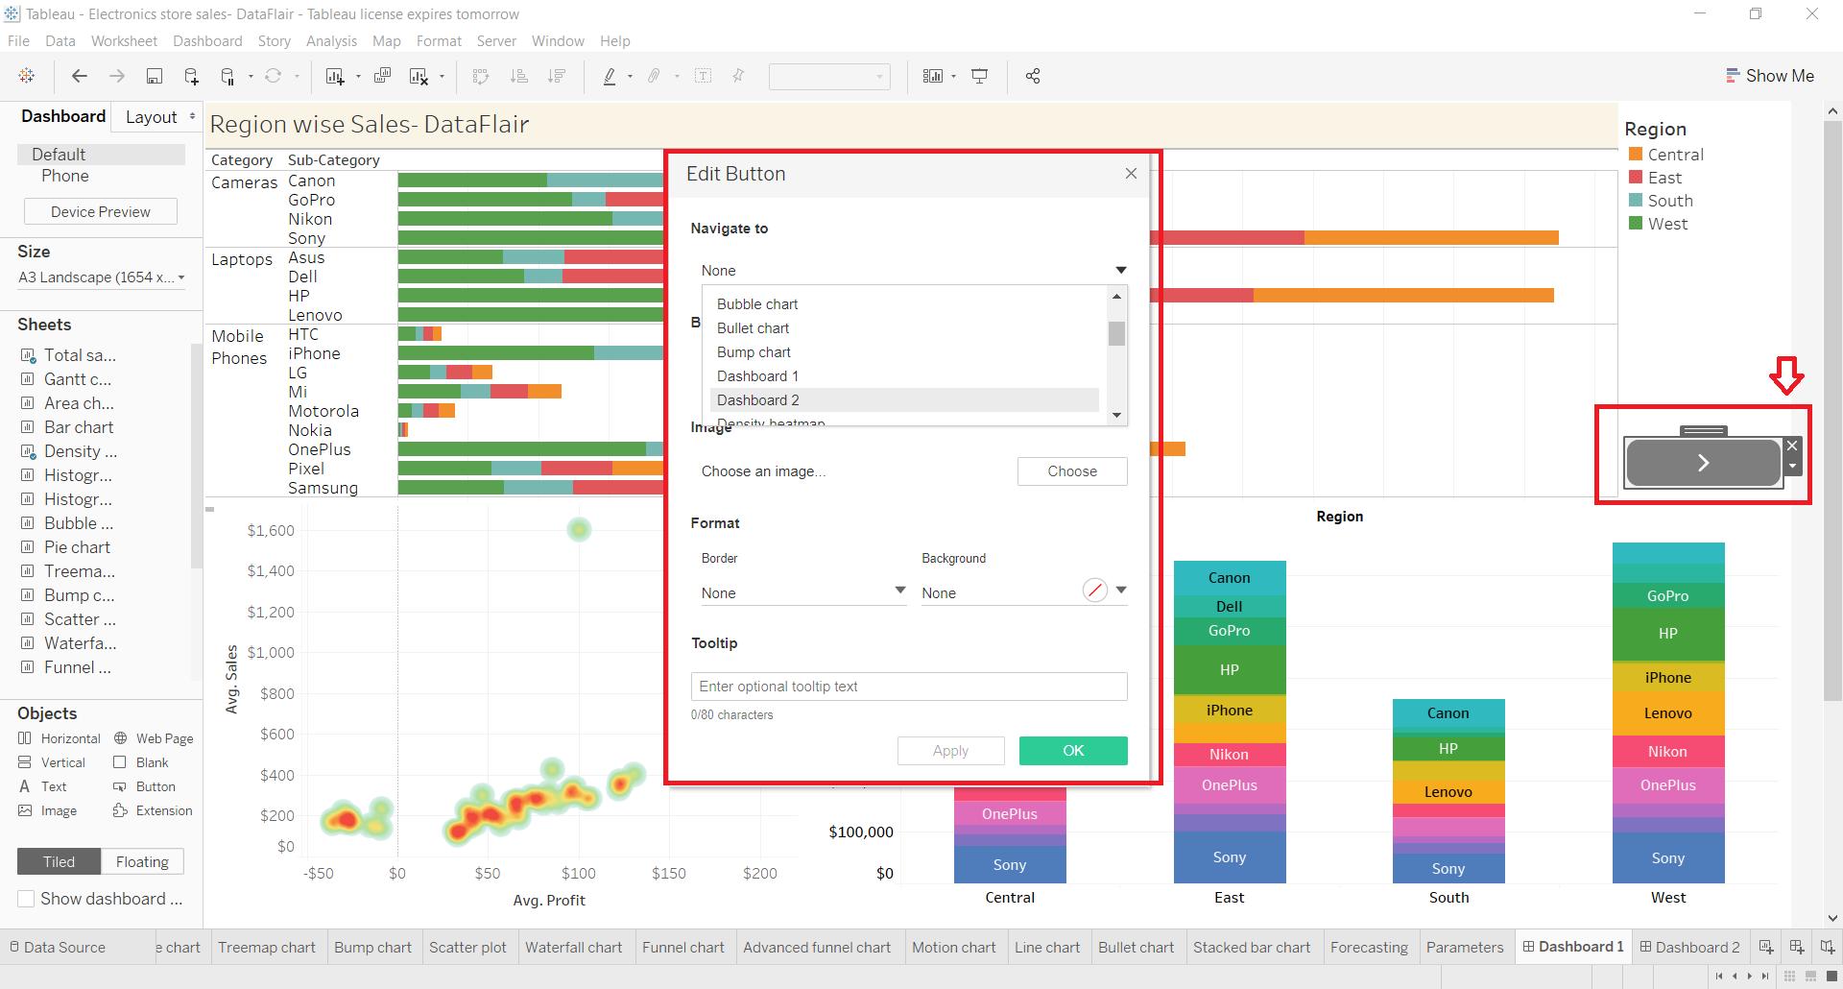](https://data-flair.training/blogs/wp-content/uploads/sites/2/2019/11/objects-pane.png)

For instance, we add a web page of our DataFlair official site as shown in the screenshot below.

[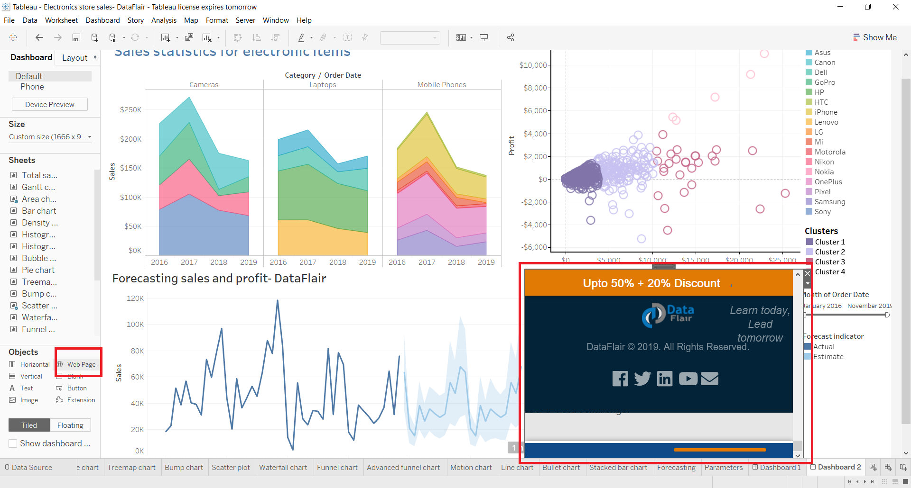](https://data-flair.training/blogs/wp-content/uploads/sites/2/2019/11/add-web-page.png)

**7. Final dashboard**

Now, we move towards making a final dashboard in [Tableau](https://www.tableau.com/) with all its elements in place. As you can see in the screenshot below, we have three main visualizations on our current dashboard i.e. a segmented area chart, [***scatter chart***](https://data-flair.training/blogs/tableau-scatter-plot/)and a line chart showing the sales and profits forecast. On the right pane, we have the list of legends showing Sub-category names, a forecast indicator and a list of clusters.

[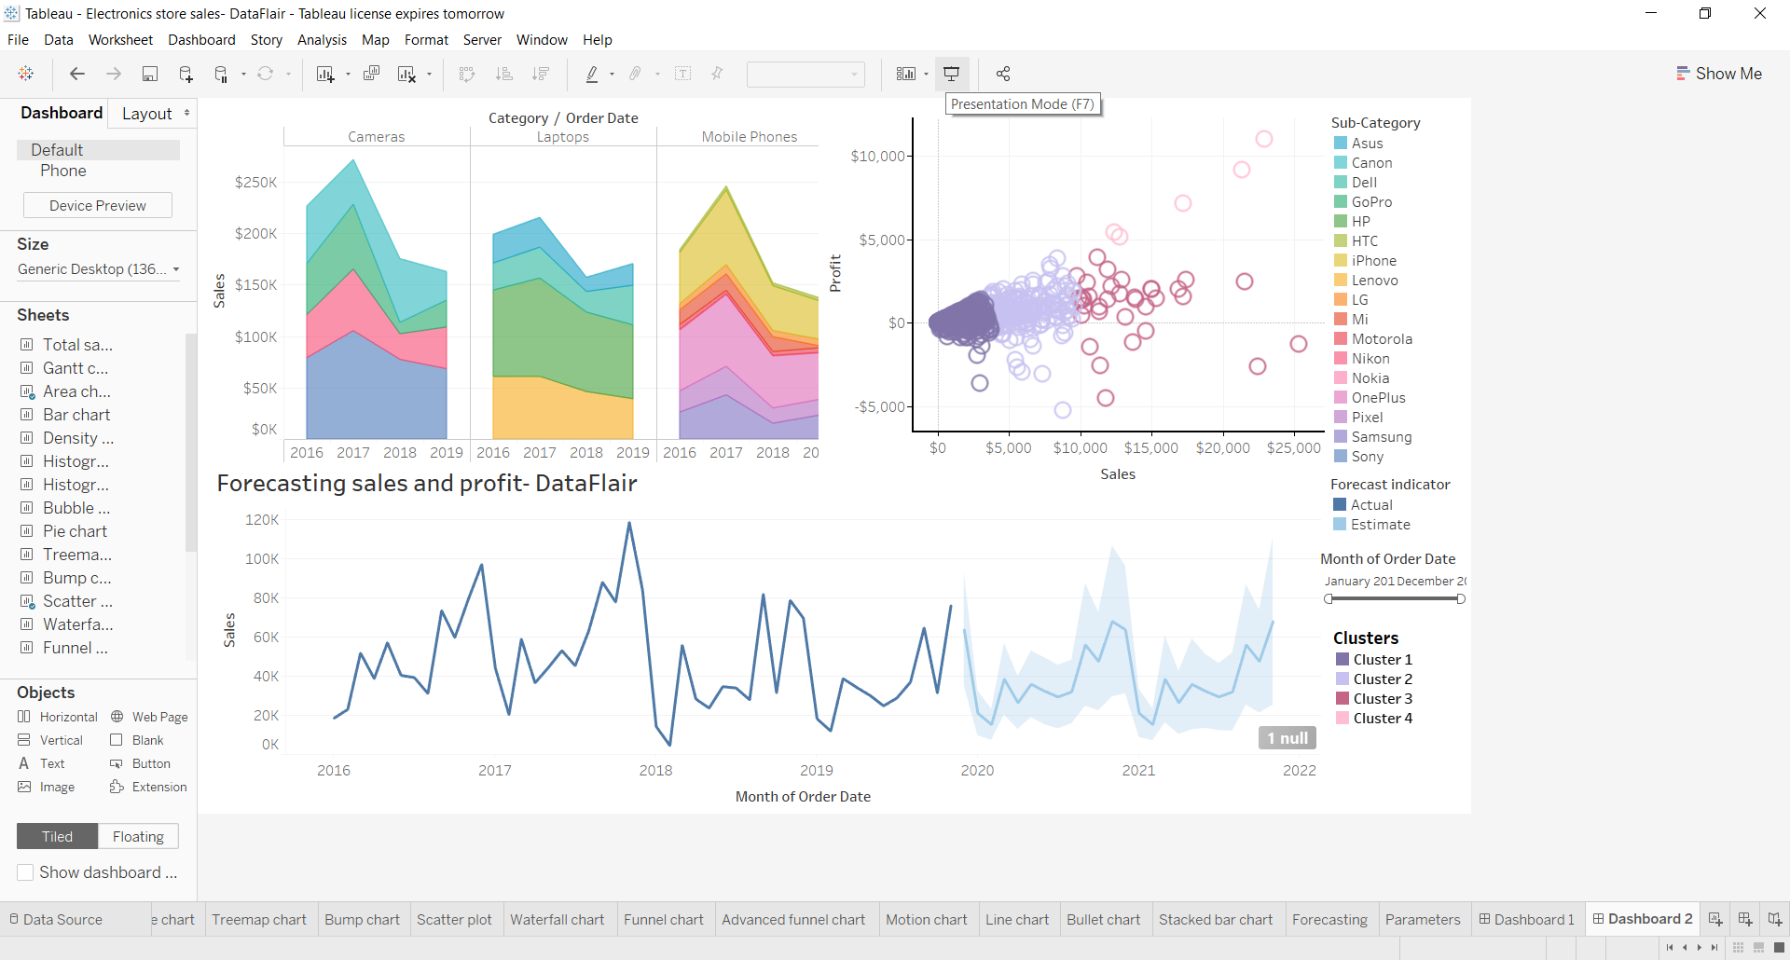](https://data-flair.training/blogs/wp-content/uploads/sites/2/2019/11/Final-Dashboard.png)

We can add filters on this dashboard by clicking on a visual. For instance, we want to add a filter based on months on the scatter plot showing sales values for different clusters. To add a months filter, we click on the small **downward arrow** and then select **Filters** option. Then we select **Months of Order Date** option. You can select any field based on which you wish to create a new filter.

[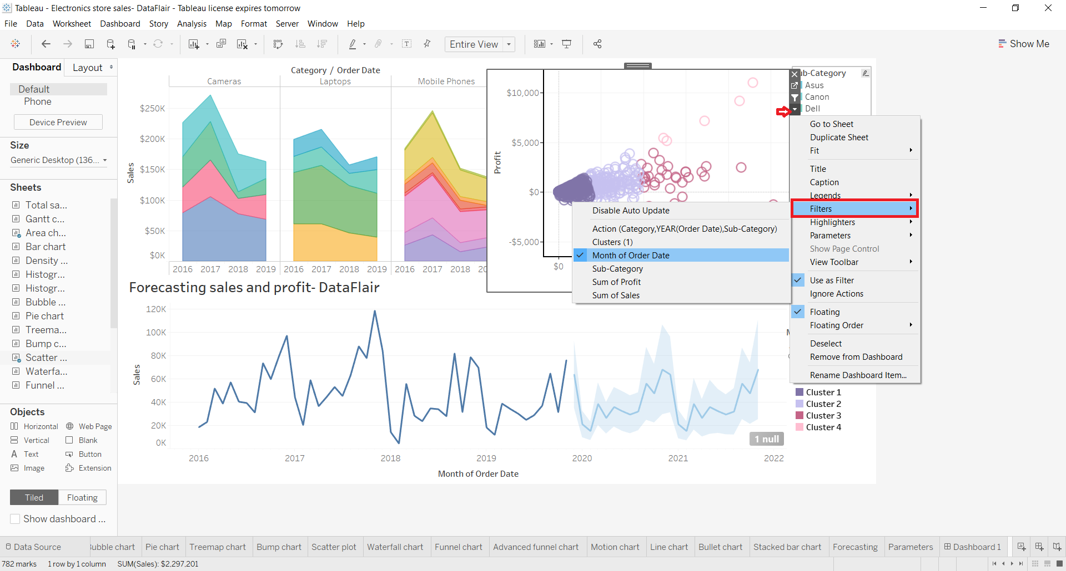](https://data-flair.training/blogs/wp-content/uploads/sites/2/2019/11/add-months-filter.png)

This will give us a slider filter to select a range of months for which we want to see our data. You can adjust the position of the filter box and drag and drop it at whichever place you want.

[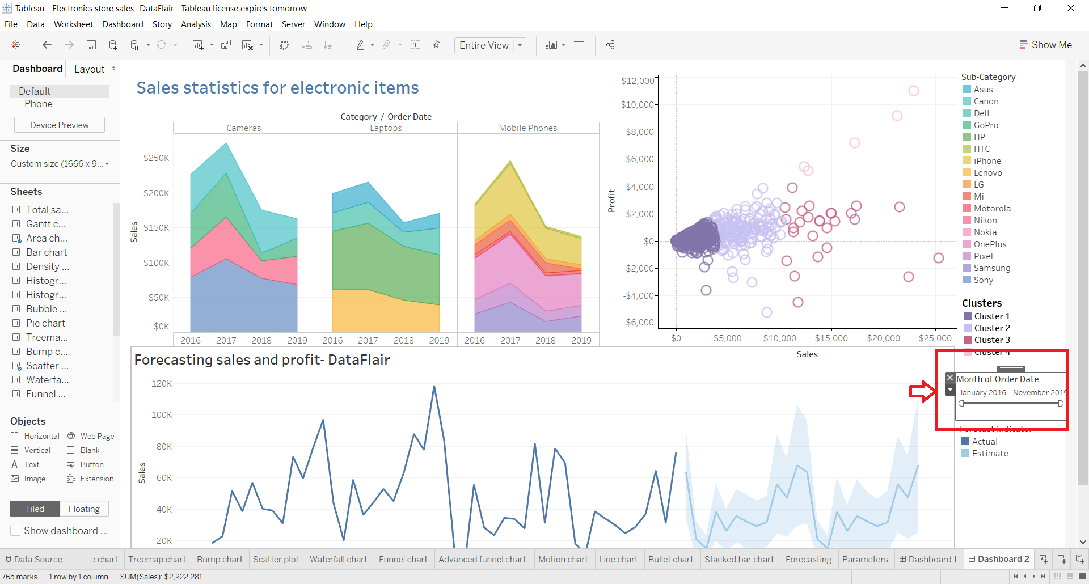](https://data-flair.training/blogs/wp-content/uploads/sites/2/2019/11/slider-filter-for-months-range.png)

You can make more changes into the filter by right-clicking on it. Also, you can change the type of filter from the drop-down menu such as Relative Date, Range of Date, Start Date, End Date, Browse Periods, etc.

[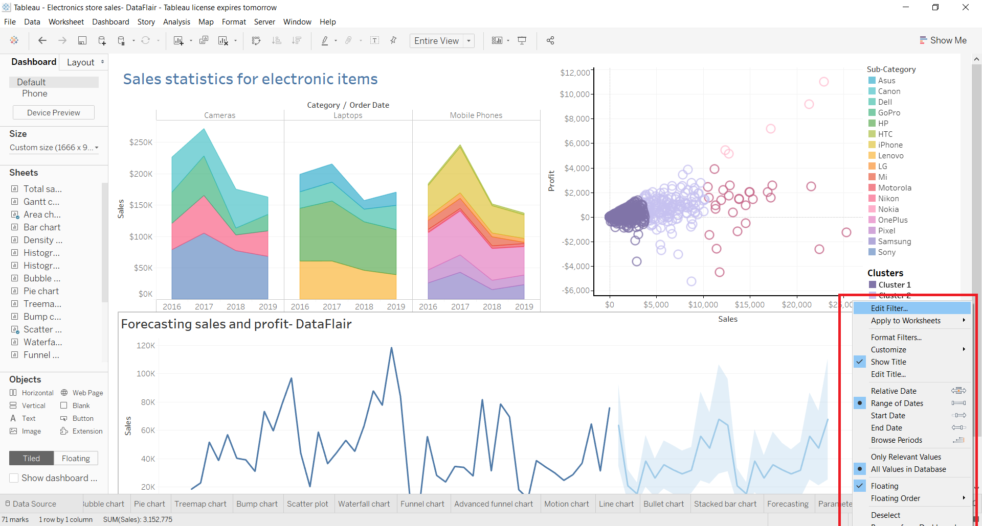](https://data-flair.training/blogs/wp-content/uploads/sites/2/2019/11/change-filter-type.png)

Similarly, you can add and edit more filters on the dashboard.

**8. Presentation mode**

Once our dashboard is ready, we can view it in the **Presentation Mode**. To enable the presentation mode, click on the icon present on the bar at the top as shown in the screenshot below or press F7.

[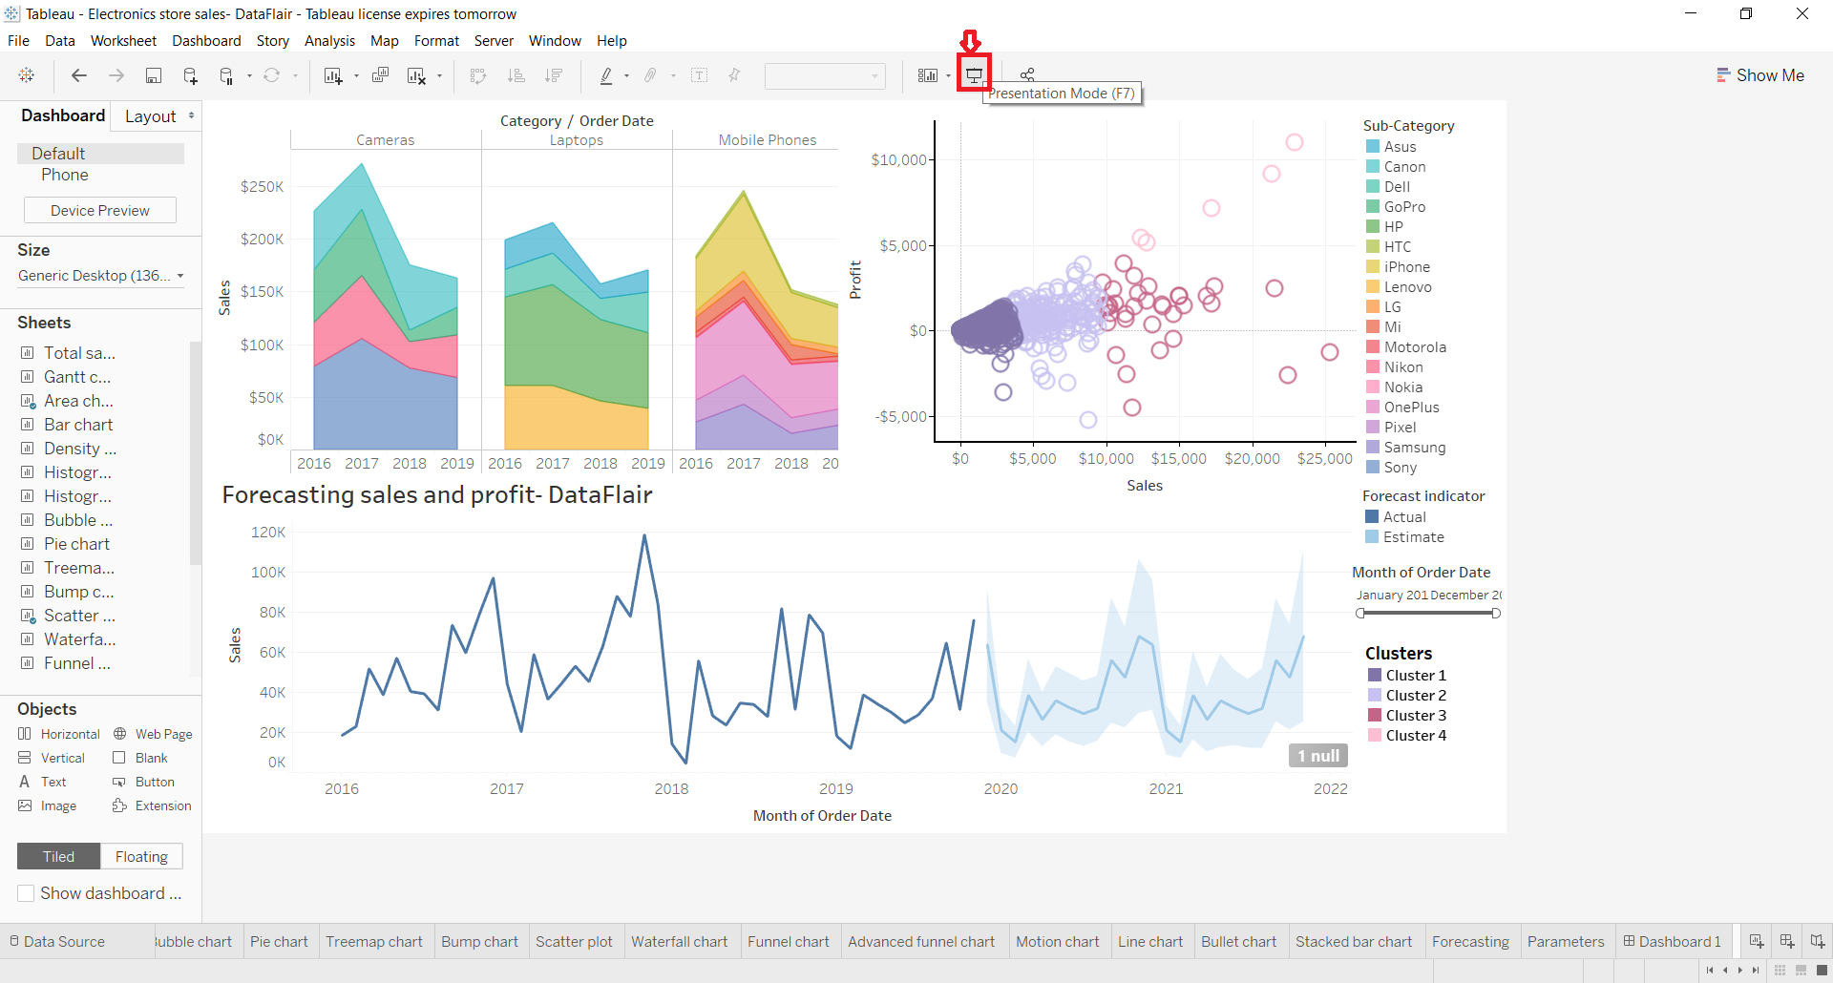](https://data-flair.training/blogs/wp-content/uploads/sites/2/2019/11/Presentation-mode.png)

This opens our dashboard in the presentation mode. So far we were working in the Edit Mode. In the presentation mode, it neatly shows all the visuals and objects that we have added on the dashboard. We can see how the dashboard will look when we finally present it to others or share it with other people for analysis.

[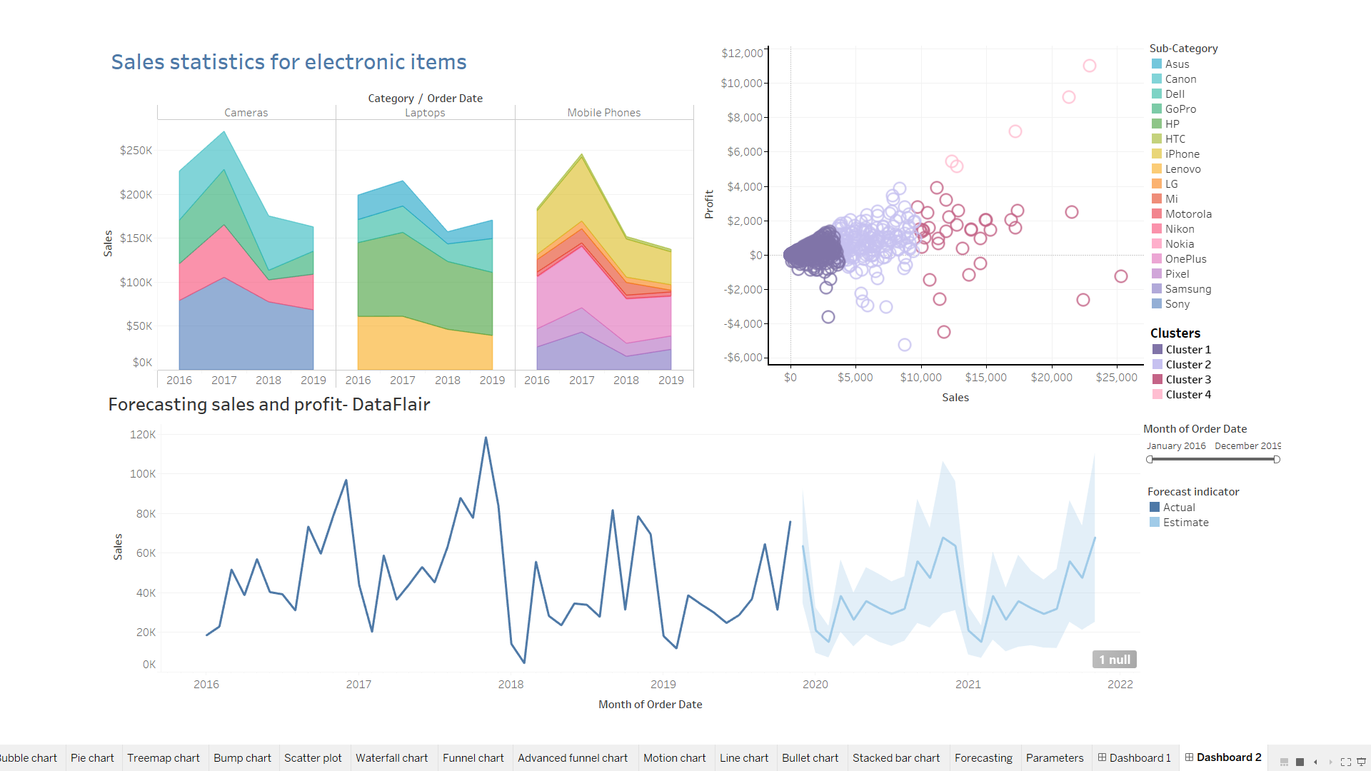](https://data-flair.training/blogs/wp-content/uploads/sites/2/2019/11/presentation-mode-active.png)

Here, we can also apply the filter range to our data. The dashboard is interactive and will change the data according to the filters we apply or selections we make.

[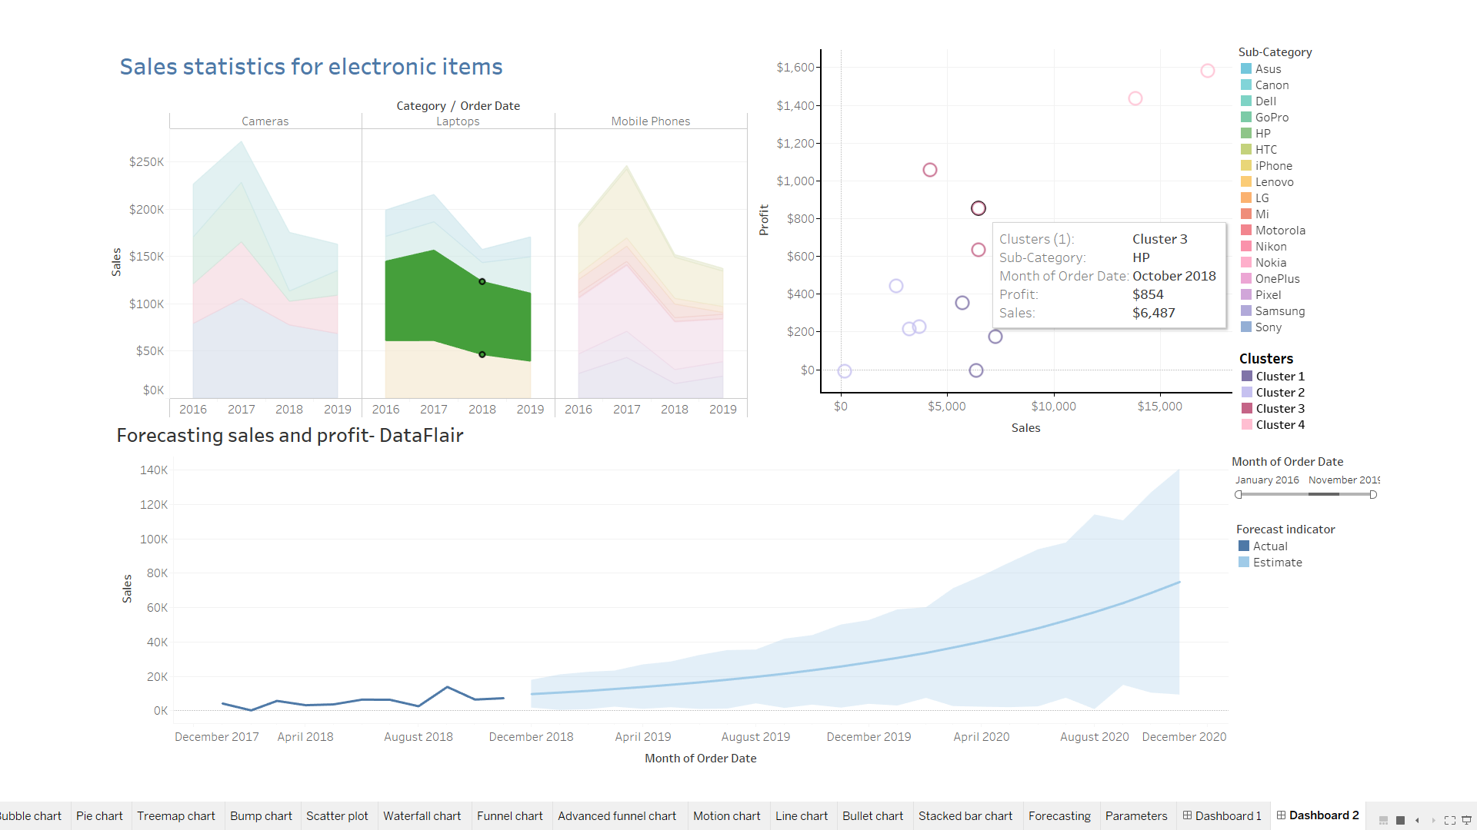](https://data-flair.training/blogs/wp-content/uploads/sites/2/2019/11/make-selections.png)

For instance, we selected the brand Pixel from our list of items from the sub-category field. This instantly changes the information on the visuals and makes it relevant to only Pixel.

**9. Share workbook with others**

We can also share all the worksheets and dashboard that we create together as a workbook with other users. To share the workbook with others, click on the **share** icon (highlighted in red). Next, you need to enter the server address of a Tableau server.

**Note –** You must have a Tableau Online or Tableau Server account in order to do this.

[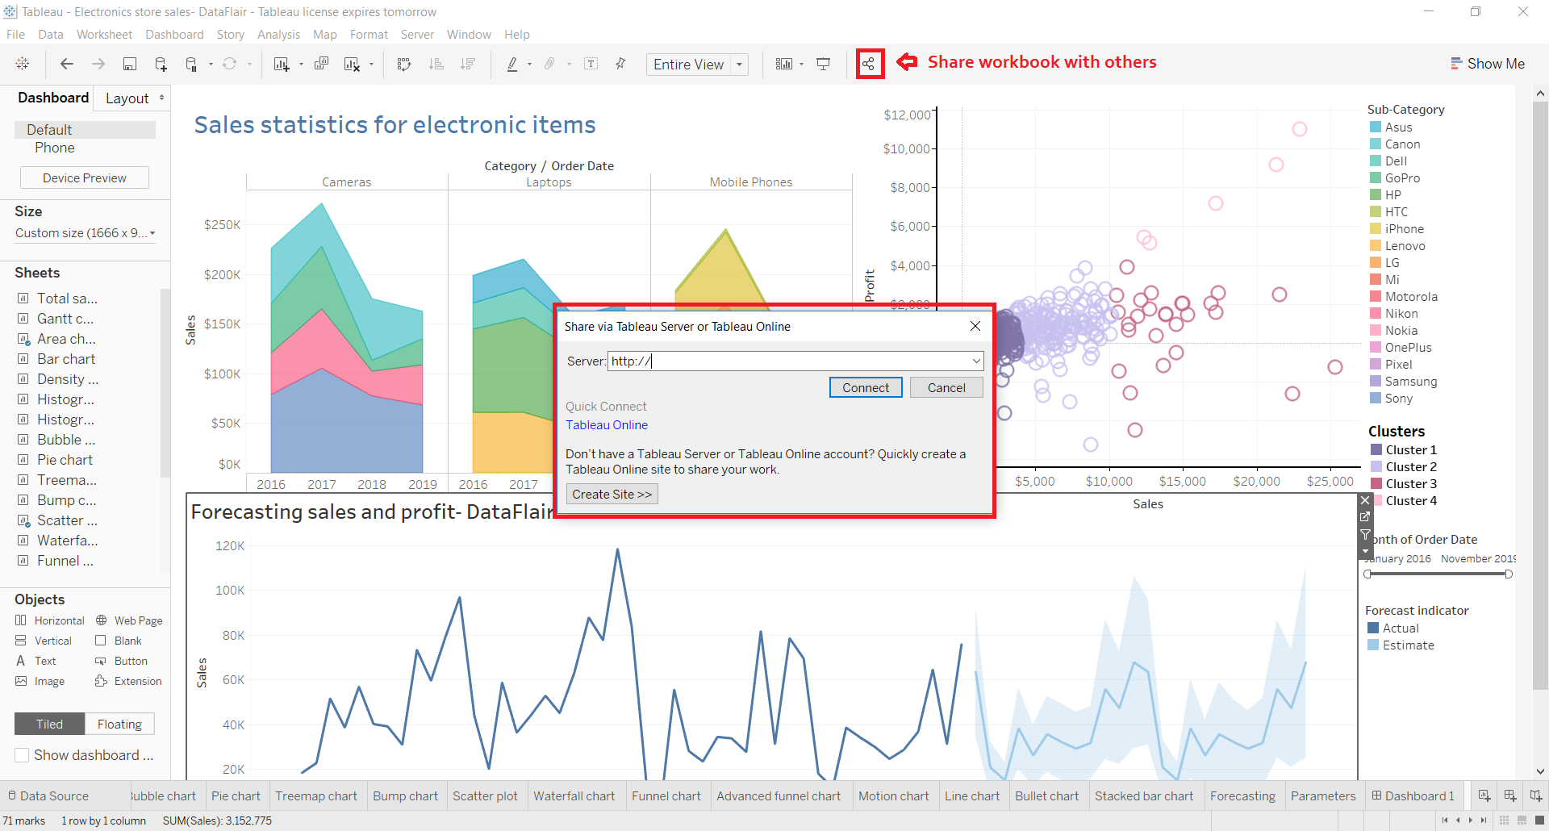](https://data-flair.training/blogs/wp-content/uploads/sites/2/2019/11/share-workbook-with-others.png)

## Logical Functions in Tableau:

## Tableau Logical Functions | Logical statements

|  |  |  |
| --- | --- | --- |
| ***Function*** | ***Syntax*** | ***Description*** |
| **IN** | <expr1> IN <expr2> | Returns TRUE if any value in <expr1> matches any value in <expr2>. |
|  |
| The values in <expr1> can be a Set, list of literal values, or a combined field. |
|  |
| Examples: |
|  |
| SUM([Cost]) IN (1000, 15, 200) |
|  |
| [SET] IN [COMBINED FIELD] |
| **AND** | IF <expr1> AND <expr2> THEN <then> END | Performs a logical conjunction on two expressions. |
|  |
| Example: |
|  |
| IF (ATTR([Market]) = "Africa" AND SUM([Sales]) > [Emerging Threshold] )THEN "Well Performing" |
| **CASE** | CASE <expression> WHEN <value1> THEN <return1> WHEN <value2> THEN <return2> ... ELSE <default return> END | Performs logical tests and returns appropriate values. The CASE function evaluates expression, compares it to a sequence of values, value1, value2, etc., and returns a result. When a value that matches expression is encountered, CASE returns the corresponding return value. If no match is found, the default return expression is used. If there is no default return and no values match, then Null is returned. |
|  |
| CASE is often easier to use than IIF or IF THEN ELSE. |
|  |
| Typically, you use an IF function to perform a sequence of arbitrary tests, and you use a CASE function to search for a match to an expression. But a CASE function can always be rewritten as an IF function , although the CASE function will generally be more concise. |
|  |
| Many times you can use a group to get the same results as a complicated case function. |
|  |
| Examples: |
|  |
| CASE [Region] WHEN 'West' THEN 1 WHEN 'East' THEN 2 ELSE 3 END |
|  |
| CASE LEFT(DATENAME('weekday',[Order Date]),3) WHEN 'Sun' THEN 0 WHEN 'Mon' THEN 1 WHEN 'Tue' THEN 2 WHEN 'Wed' THEN 3 WHEN 'Thu' THEN 4 WHEN 'Fri' THEN 5 WHEN 'Sat' THEN 6 END |
| **ELSE** | IF <expr> THEN <then> ELSE <else> END | Tests a series of expressions returning the <then> value for the first true <expr>. |
|  |
| Example: |
|  |
| If [Profit] > 0 THEN 'Profitable' ELSE 'Loss' END |
| **ELSEIF** | IF <expr> THEN <then> [ELSEIF <expr2> THEN <then2>...] [ELSE <else>] END | Tests a series of expressions returning the <then> value for the first true <expr>. |
|  |
| Example: |
|  |
| IF [Profit] > 0 THEN 'Profitable' ELSEIF [Profit] = 0 THEN 'Breakeven' ELSE 'Loss' END |
| **END** | IF <expr> THEN <then> [ELSEIF <expr2> THEN <then2>...] [ELSE <else>] END | Tests a series of expressions returning the <then> value for the first true <expr>. Must be placed at the end of an expression. |
|  |
| Example: |
|  |
| IF [Profit] > 0 THEN 'Profitable' ELSEIF [Profit] = 0 THEN 'Breakeven' ELSE 'Loss' END |
| **IF** | IF <expr> THEN <then> [ELSEIF <expr2> THEN <then2>...] [ELSE <else>] END | Tests a series of expressions returning the <then> value for the first true <expr>. |
|  |
| Example: |
|  |
| IF [Profit] > 0 THEN 'Profitable' ELSEIF [Profit] = 0 THEN 'Breakeven' ELSE 'Loss' END |
| **IFNULL** | IFNULL(expr1, expr2) | Returns <expr1> if it is not null, otherwise returns <expr2>. |
|  |
| Example: |
|  |
| IFNULL([Profit], 0) |
| **IIF** | IIF(test, then, else, [unknown]) | Checks whether a condition is met, and returns one value if TRUE, another value if FALSE, and an optional third value or NULL if unknown. |
|  |
| Example: |
|  |
| IIF([Profit] > 0, 'Profit', 'Loss') |
| **ISDATE** | ISDATE(string) | Returns true if a given string is a valid date. |
|  |
| Example: |
|  |
| ISDATE("2004-04-15") = True |
| **ISNULL** | ISNULL(expression) | Returns true if the expression is NULL (does not contain valid data). |
|  |
| Example: |
|  |
| ISNULL([Profit]) |
| **MAX** | MAX(expression) or Max(expr1, expr2) | Returns the maximum of a single expression across all records or the maximum of two expressions for each record. |
|  |
| Example: |
|  |
| MAX([Sales]) |
| **MIN** | MIN(expression) or MIN(expr1, expr2) | Returns the minimum of an expression across all records or the minimum of two expressions for each record. |
|  |
| Example: |
|  |
| MIN([Profit]) |
| **NOT** | IF NOT <expr> THEN <then> END | Performs logical negation on an expression. |
|  |
| Example: |
|  |
| IF NOT [Profit] > 0 THEN "Unprofitable" END |
| **OR** | IF <expr1> OR <expr2> THEN <then> END | Performs a logical disjunction on two expressions. |
|  |
| Example: |
|  |
| IF [Profit] < 0 OR [Profit] = 0 THEN "Needs Improvement" END |
| **THEN** | IF <expre> THEN <then> [ELSEIF ,expr2> THEN <then2>...] [ELSE <else>] END | Tests a series of expressions returning the <then> value for the first true <expr>. |
|  |
| Example: |
|  |
| IF [Profit] > 0 THEN 'Profitable' ELSEIF [Profit] = 0 THEN 'Break even' ELSE 'unprofitable' END |
| **WHEN** | CASE <expr> WHEN <Value1> THEN <return1> ... [ELSE <else>] END | Finds the first <value> that matches <expr> and returns the corresponding <return>. |
|  |
| Example: |
|  |
| CASE [RomanNumberal] WHEN 'I' THEN 1 WHEN 'II' THEN 2 ELSE 3 END |
| **ZN** | ZN(expression) | Returns <expression> if it is not null, otherwise returns zero. |
|  |
| Example: |
|  |
| ZN([Profit]) |

**Tableau Aggregate Functions:**

|  |  |  |
| --- | --- | --- |
| Function | Syntax | Definition |
| **ATTR** | ATTR(expression) | Returns the value of the expression if it has a single value for all rows. Otherwise returns an asterisk. Null values are ignored. |
| **AVG** | AVG(expression) | Returns the average of all the values in the expression. AVG can be used with numeric fields only. Null values are ignored. |
| **COLLECT** | COLLECT (spatial) | An aggregate calculation that combines the values in the argument field. Null values are ignored. |
|  |
| **Note**: The COLLECT function can only be used with spatial fields. |
|  |
| Example: |
|  |
| COLLECT ([Geometry]) |
| **CORR** | CORR(expression 1, expression2) | Returns the Pearson correlation coefficient of two expressions. |
|  |
| The Pearson correlation measures the linear relationship between two variables. Results range from -1 to +1 inclusive, where 1 denotes an exact positive linear relationship, as when a positive change in one variable implies a positive change of corresponding magnitude in the other, 0 denotes no linear relationship between the variance, and −1 is an exact negative relationship. |
|  |
| CORR is available with the following data sources: |
|  |
| Tableau data extracts (you can create an extract from any data source) |
| Cloudera Hive |
| EXASolution |
| Firebird (version 3.0 and later) |
| Google BigQuery |
| Hortonworks Hadoop Hive |
| IBM PDA (Netezza) |
| Oracle |
| PostgreSQL |
| Presto |
| SybaseIQ |
| Teradata |
| Vertica |
|  |
| [For other data sources, consider either extracting the data or using WINDOW_CORR. See Table Calculation Functions.](https://help.tableau.com/current/pro/desktop/en-us/functions_functions_tablecalculation.htm) |
|  |
| [Note: The square of a CORR result is equivalent to the R-Squared value for a linear trend line model. See Trend Line Model Terms.](https://help.tableau.com/current/pro/desktop/en-us/trendlines_add.htm#Terms) |
|  |
| Example: |
|  |
| You can use CORR to visualize correlation in a disaggregated scatter plot. The way to do this is to use a table-scoped level of detail expression. For example: |
|  |
| {CORR(Sales, Profit)} |
|  |
| With a level of detail expression, the correlation is run over all rows. If you used a formula like CORR(Sales, Profit) (without the surrounding brackets to make it a level of detail expression), the view would show the correlation of each individual point in the scatter plot with each other point, which is undefined. |
|  |
| [See Table-Scoped](https://help.tableau.com/current/pro/desktop/en-us/calculations_calculatedfields_lod.htm#Table) |
| **COUNT** | COUNT(expression) | Returns the number of items in a group. Null values are not counted. |
| **COUNTD** | COUNTD(expression) | [Returns the number of distinct items in a group. Null values are not counted. This function is not available in the following cases: workbooks created before Tableau Desktop 8.2 that use Microsoft Excel or text file data sources, workbooks that use the legacy connection, and workbooks that use Microsoft Access data sources. Extract your data into an extract file to use this function. See Extract Your Data.](https://help.tableau.com/current/pro/desktop/en-us/extracting_data.htm) |
| **COVAR** | COVAR(expression 1, expression2) | Returns the *sample covariance* of two expressions. |
|  |
| Covariance quantifies how two variables change together. A positive covariance indicates that the variables tend to move in the same direction, as when larger values of one variable tend to correspond to larger values of the other variable, on average. Sample covariance uses the number of non-null data points n - 1 to normalize the covariance calculation, rather than n, which is used by the population covariance (available with the COVARP function). Sample covariance is the appropriate choice when the data is a random sample that is being used to estimate the covariance for a larger population. |
|  |
| COVAR is available with the following data sources: |
|  |
| Tableau data extracts (you can create an extract from any data source) |
| Cloudera Hive |
| EXASolution |
| Firebird (version 3.0 and later) |
| Google BigQuery |
| Hortonworks Hadoop Hive |
| IBM PDA (Netezza) |
| Oracle |
| PostgreSQL |
| Presto |
| SybaseIQ |
| Teradata |
| Vertica |
|  |
| [For other data sources, consider either extracting the data or using WINDOW_COVAR. See Table Calculation Functions.](https://help.tableau.com/current/pro/desktop/en-us/functions_functions_tablecalculation.htm) |
|  |
| If expression1 and expression2 are the same—for example, COVAR([profit], [profit])—COVAR returns a value that indicates how widely values are distributed. |
|  |
| **Note**: The value of COVAR(X, X) is equivalent to the value of VAR(X) and also to the value of STDEV(X)^2. |
|  |
| Example: |
|  |
| The following formula returns the sample covariance of **Sales** and **Profit**. |
|  |
| COVAR([Sales], [Profit]) |
| **COVARP** | COVARP(expression 1, expression2) | Returns the *population covariance* of two expressions. |
|  |
| Covariance quantifies how two variables change together. A positive covariance indicates that the variables tend to move in the same direction, as when larger values of one variable tend to correspond to larger values of the other variable, on average. Population covariance is sample covariance multiplied by (n-1)/n, where n is the total number of non-null data points. Population covariance is the appropriate choice when there is data available for all items of interest as opposed to when there is only a random subset of items, in which case sample covariance (with the COVAR function) is appropriate. |
|  |
| COVARP is available with the following data sources: |
|  |
| Tableau data extracts (you can create an extract from any data source) |
| Cloudera Hive |
| EXASolution |
| Firebird (version 3.0 and later) |
| Google BigQuery |
| Hortonworks Hadoop Hive |
| IBM PDA (Netezza) |
| Oracle |
| PostgreSQL |
| Presto |
| SybaseIQ |
| Teradata |
| Vertica |
|  |
| [For other data sources, consider either extracting the data or using WINDOW_COVARP. See Table Calculation Functions.](https://help.tableau.com/current/pro/desktop/en-us/functions_functions_tablecalculation.htm) |
|  |
| If expression1 and expression2 are the same—for example, COVARP([profit], [profit])—COVARP returns a value that indicates how widely values are distributed. |
|  |
| **Note**: The value of COVARP(X, X) is equivalent to the value of VARP(X) and also to the value of STDEVP(X)^2. |
|  |
| Example: |
|  |
| The following formula returns the population covariance of **Sales** and **Profit**. |
|  |
| COVARP([Sales], [Profit]) |
| **MAX** | MAX(expression) | Returns the maximum of an expression across all records. If the expression is a string value, this function returns the last value where last is defined by alphabetical order. |
| **MEDIAN** | MEDIAN(expression) | Returns the median of an expression across all records. Median can only be used with numeric fields. Null values are ignored. This function is not available for workbooks created before Tableau Desktop 8.2 or that use legacy connections. It is also not available for connections using any of the following data sources: |
|  |
| Access |
| Amazon Redshift |
| Cloudera Hadoop |
| HP Vertica |
| IBM DB2 |
| IBM PDA (Netezza) |
| Microsoft SQL Server |
| MySQL |
| SAP HANA |
| Teradata |
|  |
| **MIN** | MIN(expression) | Returns the minimum of an expression across all records. If the expression is a string value, this function returns the first value where first is defined by alphabetical order. |
| **PERCENTILE** | PERCENTILE(expression, number) | Returns the percentile value from the given expression corresponding to the specified number. The number must be between 0 and 1 (inclusive)—for example, 0.66, and must be a numeric constant. |
|  |
| This function is available for the following data sources. |
|  |
| Non-legacy Microsoft Excel and Text File connections. |
|  |
| Extracts and extract-only data source types (for example, Google Analytics, OData, or Salesforce). |
|  |
| Sybase IQ 15.1 and later data sources. |
|  |
| Oracle 10 and later data sources. |
|  |
| Cloudera Hive and Hortonworks Hadoop Hive data sources. |
|  |
| EXASolution 4.2 and later data sources. |
|  |
| **STDEV** | STDEV(expression) | Returns the statistical standard deviation of all values in the given expression based on a sample of the population. |
| **STDEVP** | STDEVP(expression) | Returns the statistical standard deviation of all values in the given expression based on a biased population. |
| **SUM** | SUM(expression) | Returns the sum of all values in the expression. SUM can be used with numeric fields only. Null values are ignored. |
| **VAR** | VAR(expression) | Returns the statistical variance of all values in the given expression based on a sample of the population. |
| **VARP** | VARP(expression) | Returns the statistical variance of all values in the given expression on the entire population. |

**User Functions:**

### a. Tableau FULLNAME Perform

FULLNAME( ) – User Function in Tableau

The FULLNAME perform can come to the total name for this user. this is often the Tableau Server or Tableau on-line name once the user is signed in. the exclusion that, it’s the native or network full name for the Tableau Desktop user. Here’s an associate example:  
[Author]=FULLNAME() = ‘Carly Capitula’

### b. Tableau ISFULLNAME Perform

ISFULLNAME(string) – Tableau User Function  
This perform returns true if the user’s full name matches the required string or false if it doesn’t match. Here’s an associate example:  
ISFULLNAME(“Carly Capitula”) = TRUE

### c. Tableau ISMEMBEROF Perform

ISMEMBEROF(string) – User Function in Tableau  
The IsMemberOf perform returns true if the logged-in person presently mistreatment Tableau may be a member of the cluster that matches the string. If the person isn’t signed in, then it returns false. Here’s an associate example:  
ISMEMBEROF(“INTERWORKS”) = TRUE

### d. Tableau ISUSERNAME Perform

ISUSERNAME(string) – Tableau User Function  
Another true/false take a look at, the IsUserName perform can come true if the logged-in user’s username matches the string. Here’s an associate example:  
ISUSERNAME(“ccapitula”) = TRUE

### e. Tableau USERDOMAIN Perform

USERDOMAIN( ) – User Function in Tableau  
This perform returns the domain for this user once the user is signed into Tableau Server. it’ll come to the Windows domain if the Tableau user is on a website. The perform can come to a null string otherwise. Here’s an associate example:  
USERDOMAIN() = interworks1

### f. Tableau USERNAME Perform

USERNAME( ) – Tableau User Function  
The Username performs can come with the username of this user. This is often the Tableau Server or Tableau on-line username if the user signs in. If the user does not sign in, then it’s the native or network username for the Tableau Desktop user. Here’s an associate example:  
[Author]=USERNAME() = ‘ccapitula’

**Type of Charts:**

### 1. Bar Chart

A Bar chart organizes the data into rectangular bars that can easily be used to compare data sets. You can create a bar chart if you want to compare two or more data values of a similar kind and if you don’t have too many data groups to display. However, bar charts show discrete data so it might not be a good idea to use them if you want continuous data.

You can create a bar chart in Tableau using the Show Me option. A bar chart requires 0 or more dimensions and 1 or more measures. In Tableau, dimensions are fields that cannot be aggregated like Customer ID, Customer Names, etc. while measures are fields that can be measured or aggregated like profit, sales, etc. In the below screenshot, we have created a bar chart to show the Sum of sales for different Customer Segments.

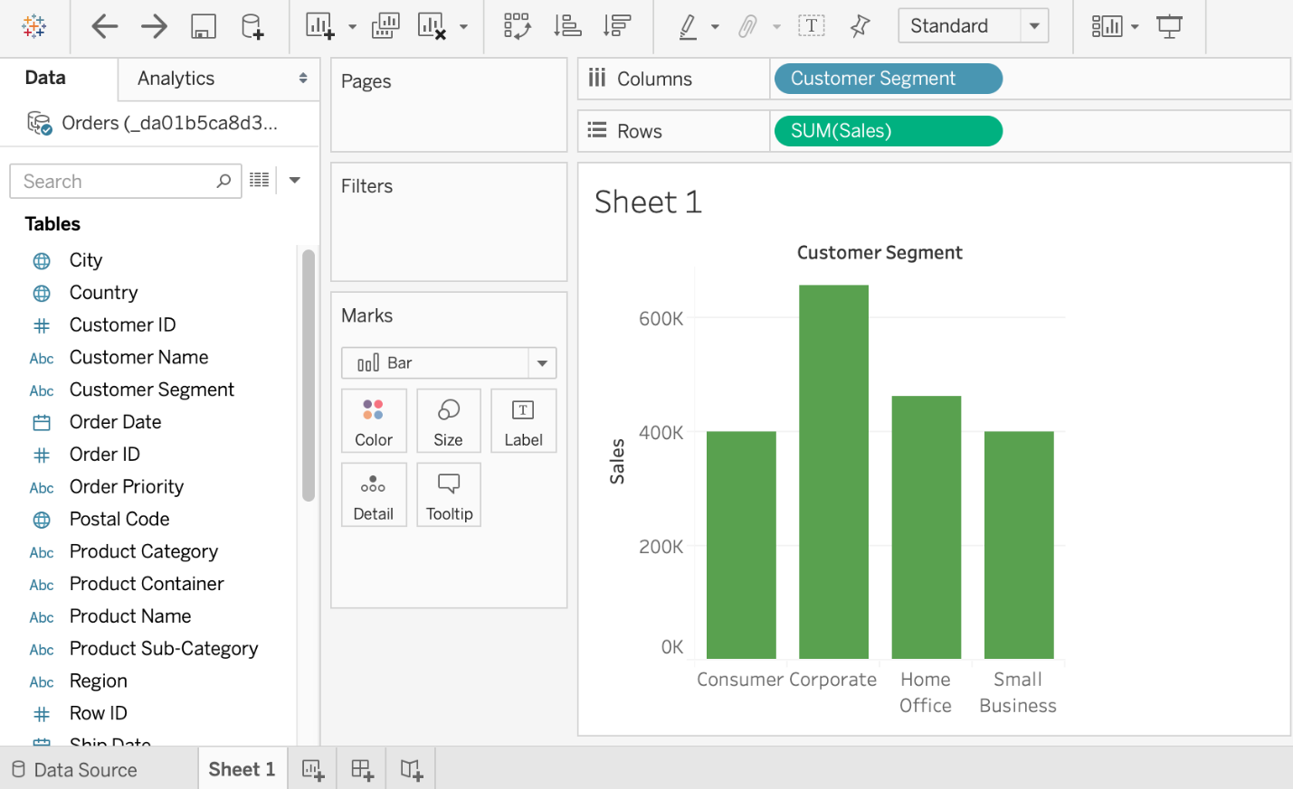

### 2. Line Chart

A-Line Chart visualizes data in the form of a line that is very useful in understanding trends and patterns. It’s best to use the Line Chart if you want to show data relative to a continuous variable like time. Different colored lines for different variables in the data make it very easy to understand a line chart.

You can create a Line Chart in Tableau using the Show Me option. A-Line Chart requires 0 or more dimensions and 1 or more measures. In the below screenshot, we have created a Line Chart to show the Sum of sales for different Customer Segments.

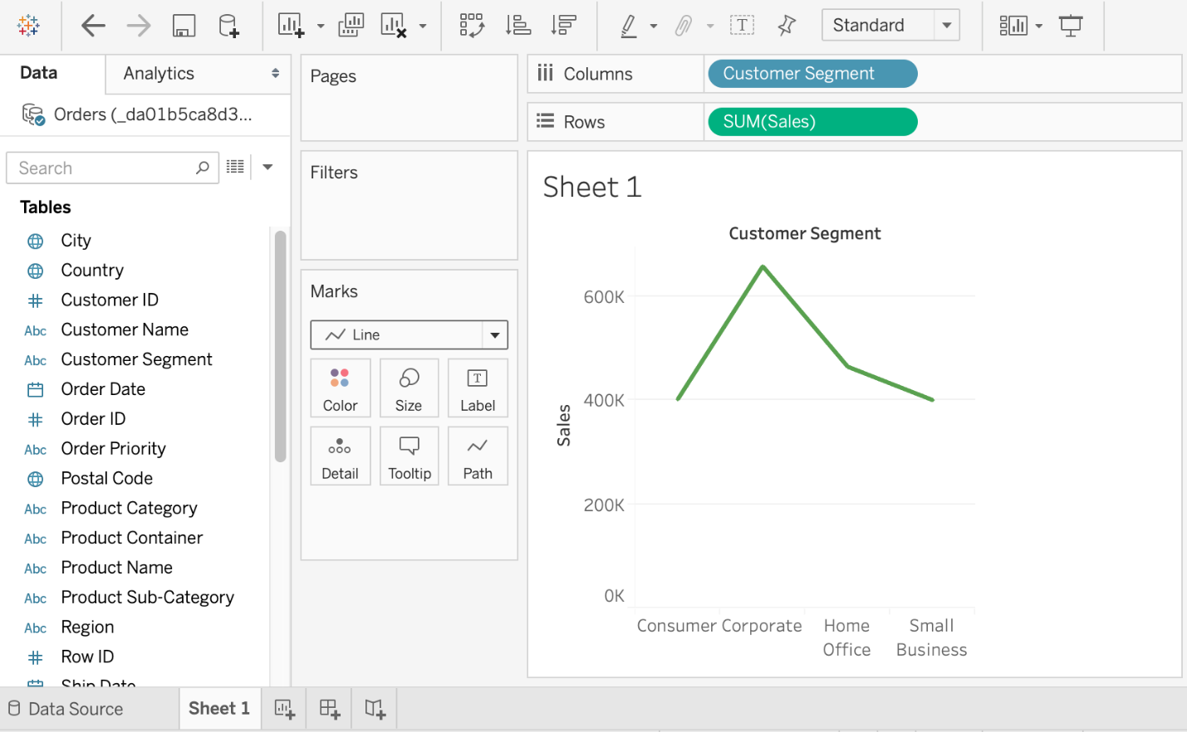

### 3. Area Chart

An Area Chart is similar to a Line Chart in that it also visualizes the data in the form of a line that is very useful in understanding trends and patterns. However, the area under the line in an area chart is also colored. This can be used with multiple variables in the data to demonstrate the relative differences between the variables.

You can create an Area Chart in Tableau using the Show Me option. An Area Chart requires 0 or more dimensions and 1 or more measures. In the below screenshot, we have created an Area Chart to show the Average CO2 emissions for the years ranging from 2001 to 2009.

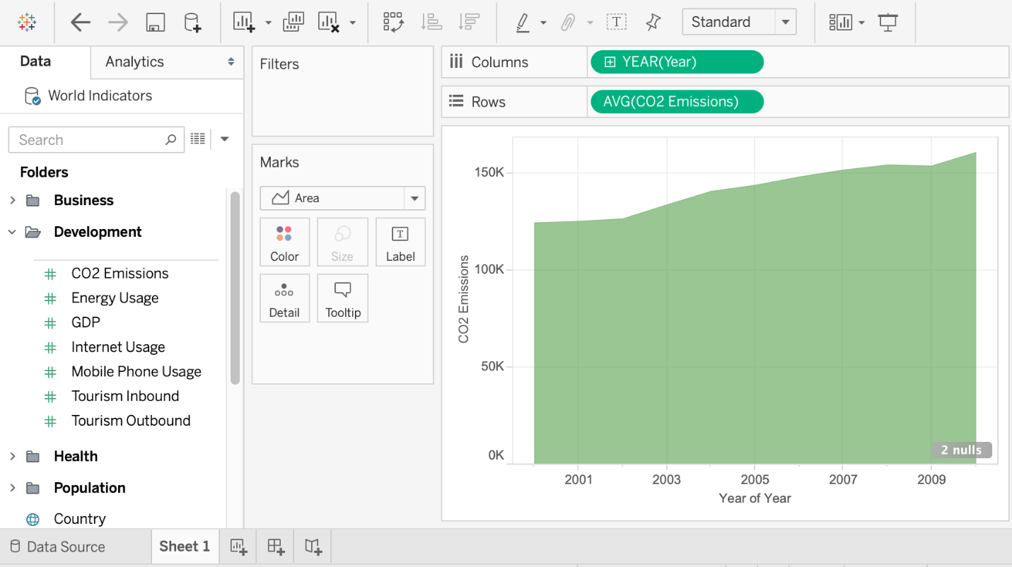

### 4. Pie Chart

A Pie chart is the best option if you want to compare some parts of the whole in the data. It can easily give an idea of the number of different parts on the whole but a disadvantage is that a pie chart is not very precise unless you add numerical values to each part of the pie chart representing the individual share on the whole.

You can create a Pie chart in Tableau using the Show Me option. A Pie chart requires 1 or more dimensions and 1 or 2 measures. In the below screenshot, we have created a Pie Chart that demonstrates the Sum of sales for different Customer Segments. The Customer Segments are demonstrated using different colors while the Sum of sales forms the pie slices in the Pie Chart.

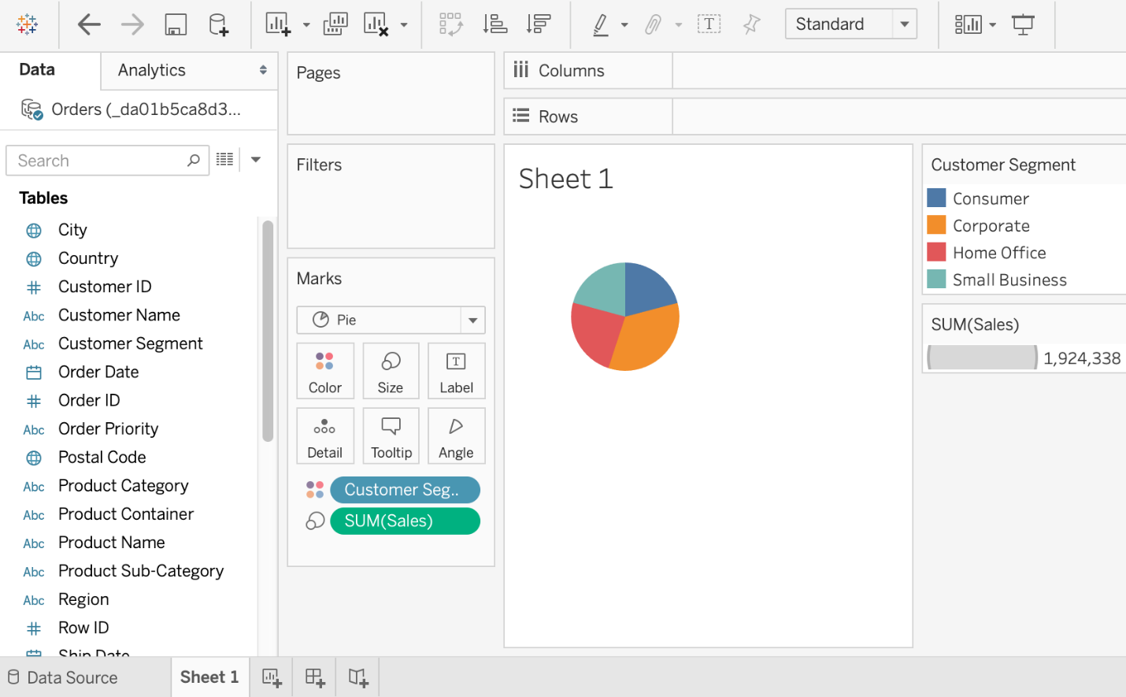

### 5. Treemap

A Treemap is used to demonstrate different parts of the data as they relate to the whole. Each rectangle in a Treemap is divided into smaller rectangles based on its proportions to the whole data like branches of a tree. So the total Treemap demonstrates the whole data while individual rectangles show the sub-data in proportion to the whole.

You can create a Treemap in Tableau using the Show Me option. A Treemap requires 1 or more dimensions and 1 or 2 measures. In the below screenshot, we have created a Treemap to show the number of products ordered for different Customer Segments. The more the number of products for a Customer Segment, the larger its rectangle in the Treemap.

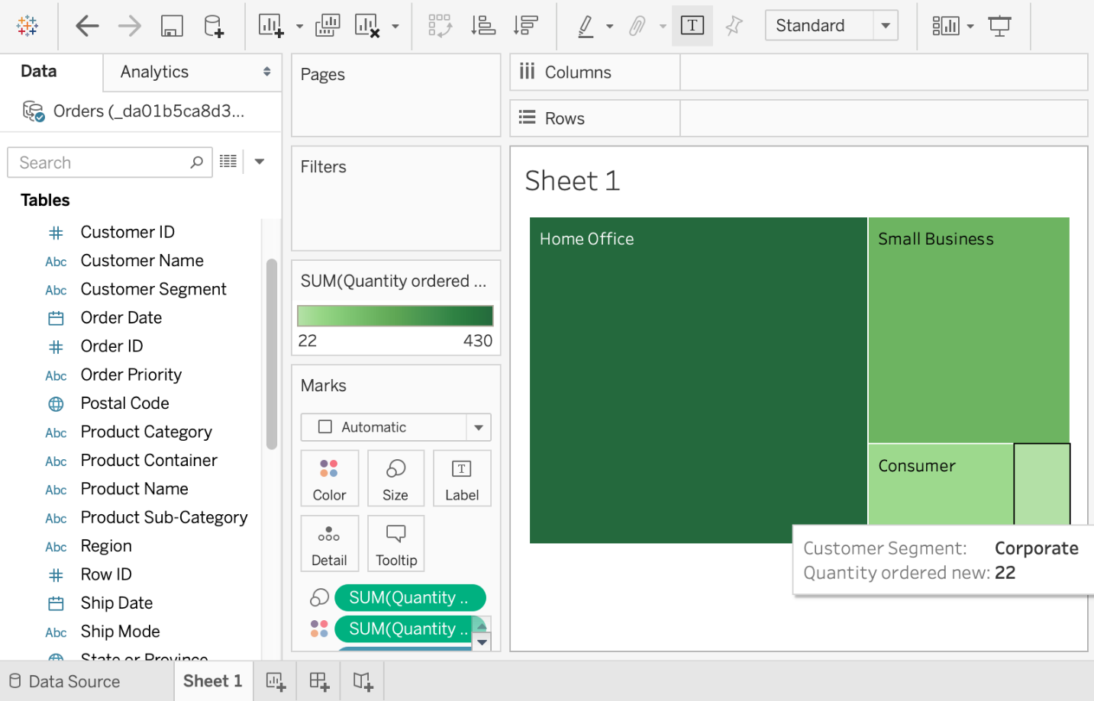

### 6. Scatter Plot

Scatterplots are used to understand the relationship between two variables in the data. You can also find the outliers in your data or understand the overall distribution by plotting a scatterplot. If the data moves from lower left to upper right, there might be a positive correlation between the two variables if the data move in the opposite direction, there might be a negative correlation.

You can create a Scatterplot in Tableau using the Show Me option. A Scatterplot requires 0 or more dimensions and 2 to 4 measures. In the below screenshot, we have created a Scatterplot to show the Sum of profits acquired for the Sum of sales for different Customer Segments.

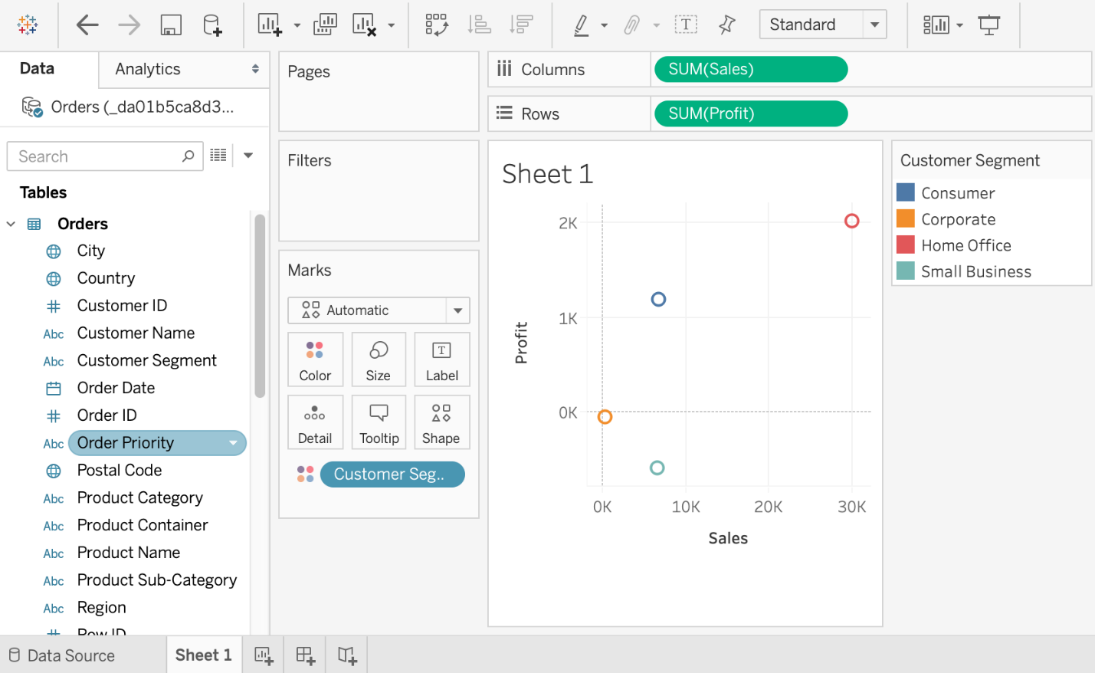

### 7. Bubble Chart

A bubble chart can be used to show the relationships between different measures and dimensions. While a bubble chart is not a full-fledged visualization on its own, it can be used along with other types of charts to add more details. The size and color of the bubbles in a bubble chart denotes various characteristics of the data in the visualization.

You can create a bubble chart in Tableau using the Show Me option. A Scatterplot requires 1 or more dimensions and 1or 2 measures. In the below screenshot, we have created a bubble chart that demonstrates the Sum of sales for various Customer segments. Each of the bubble colors denotes the different Customer segments while the size of the bubble indicates the Sum of sales.

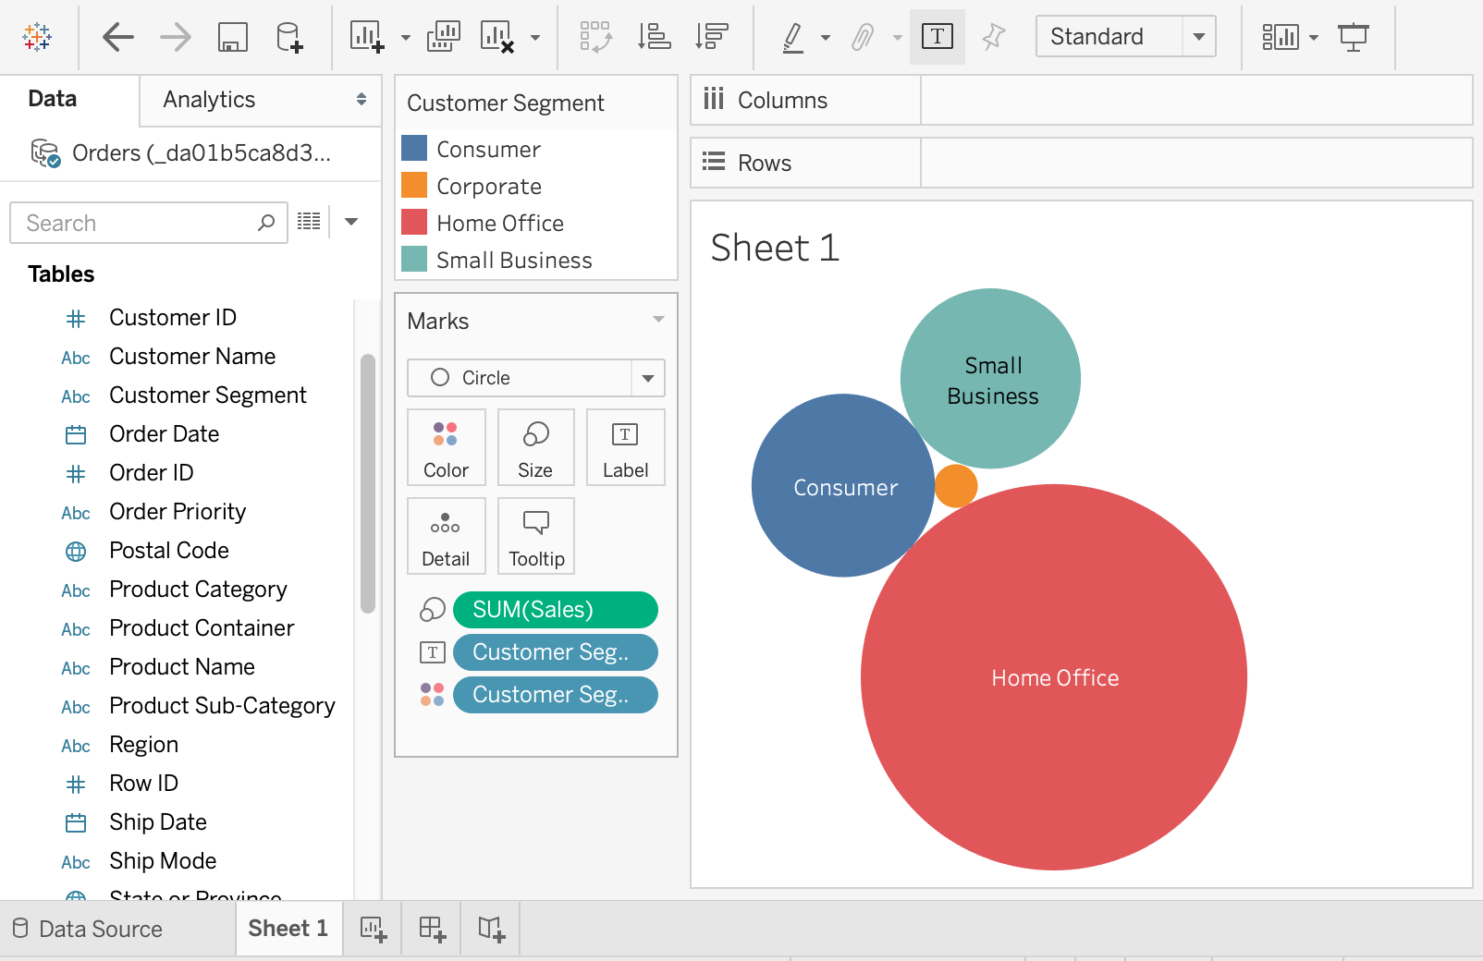

### 8. Symbol Map

A Symbol Map visualizes the data on top of a map of a geographical location. It is best to use this map if the data has geography as an important part with different bubble or any other symbol demonstrating data meaning on the map.

You can create a Symbol Map in Tableau using the Show Me option. A Symbol Map requires a geographical dimension, 0 or more dimensions, and 0 to 2 measures. In the below screenshot, we have created a Symbol Map that demonstrates the Average CO2 emissions in different countries of the world. The size of the bubble indicates the Average CO2 emissions with a larger bubble meaning more emissions.

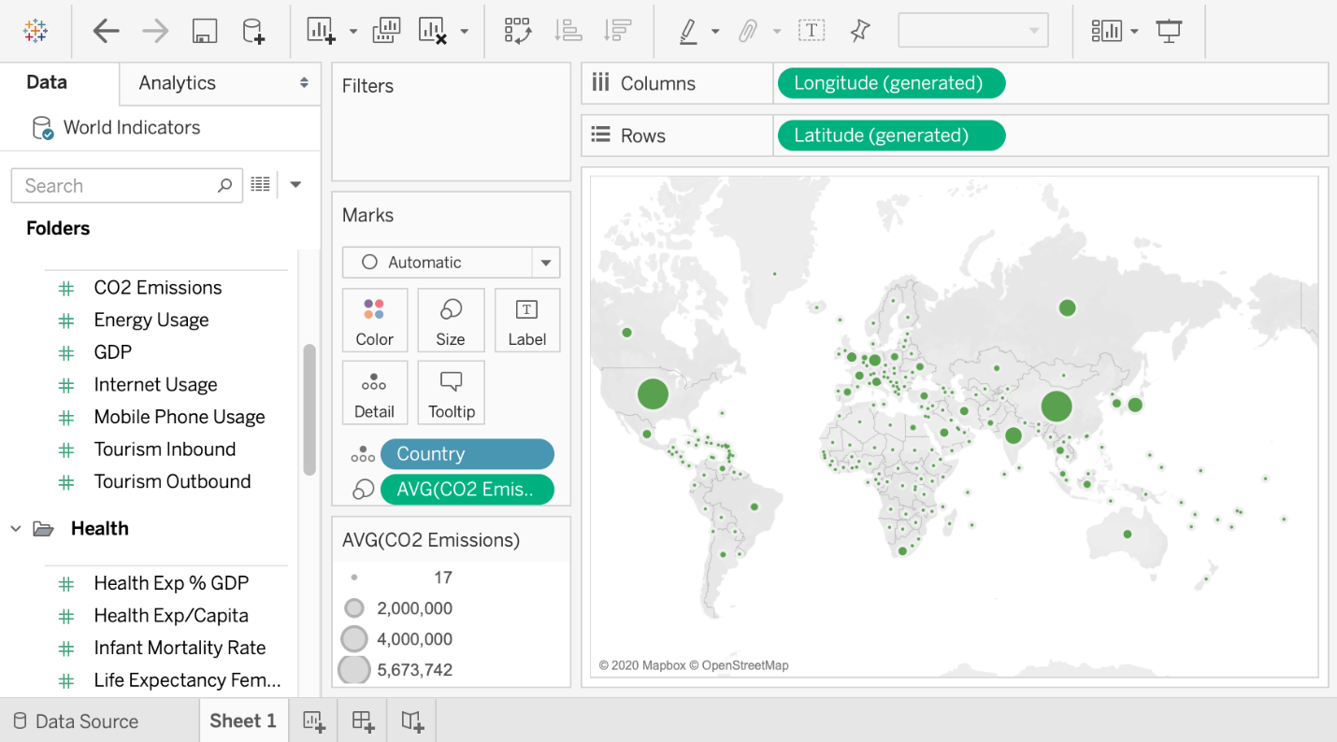

### 9. Density Map

A Density Map visualizes the data on top of a map of a geographical location. It is best to use this map if the data has geography as an important part with different shades of the same color representing different data meanings on the map. However, if you want to show precise points of data, then a Density Map is not the best idea.

A Density Map is represented by Maps in Tableau and you can create one using the Show Me option. A Density Map requires a geographical dimension, 0 or more dimensions, and 0 or 1 measures. In the below screenshot, we have created a Density Map that demonstrates the Average CO2 emissions in different countries of the world. The color of the country indicates the Average CO2 emissions with a darker color meaning more emissions.

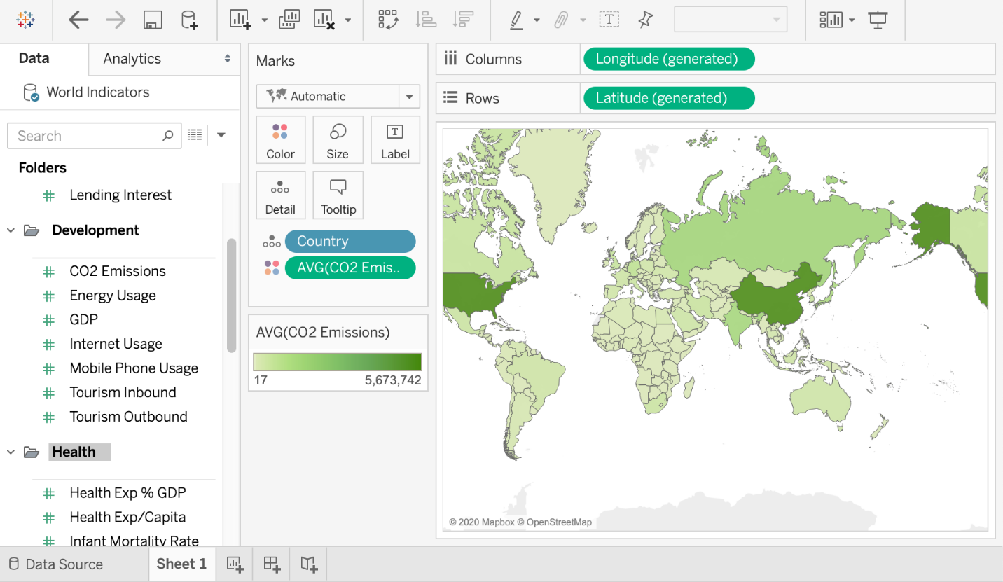

### 10. Heat Map

A Heat map provides the relationship between two variables in the data along with rating information between these variables. This rating information is normally displayed using various parameters such as shades of the same color, increasing or decreasing size, etc.

You can create a Heat map in Tableau using the Show Me option. A Heat map requires 1 or more dimensions and 1 or 2 measures. In the below screenshot, we have created a Heat map that demonstrates the Average CO2 emissions in different regions of the world across the years 2000 to 2010. The size of the squares indicates the Average CO2 emissions with a larger size meaning more emissions.

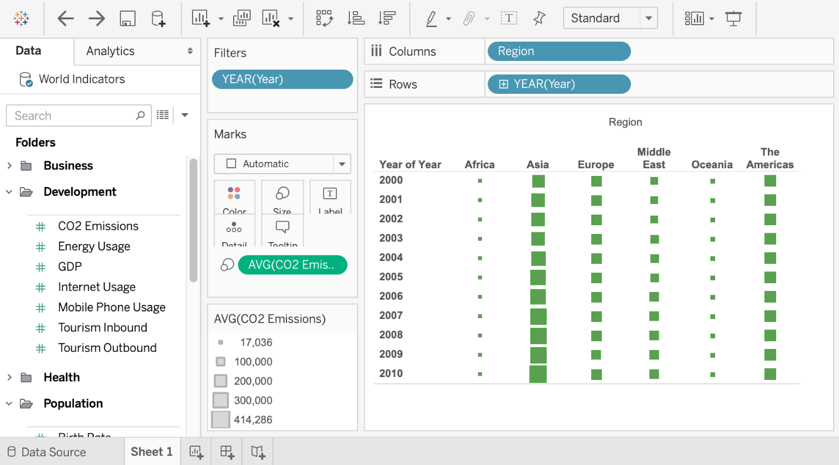

**Actions:**

Add context and interactivity to your data using actions. Users interact with your visualizations by selecting marks, or hovering, or clicking a menu, and the actions you set up can respond with navigation and changes in the view.

For example, in a dashboard showing home sales by neighborhood, you could use actions to display relevant information for a selected neighborhood. Selecting a neighborhood in one view can trigger an action that highlights the related houses in a map view, filters a list of the houses sold, then opens an external web page showing census data for the neighborhood. For related information and examples, see [A Rough Guide to Dashboard Actions(Link opens in a new window)](https://public.tableau.com/en-us/s/blog/2015/06/rough-guide-dashboard-actions) on the Tableau Public blog.

Here's how you use the different types of actions:

* **Filter**. Use the data from one view to filter data in another to help guide analysis.
* **Highlight**. Call attention to marks of interest by coloring specific marks and dimming all others.
* **Go to URL**. Create hyperlinks to external resources, such as a web page, file, or another Tableau worksheet.
* **Go to Sheet**. Simplify navigation to other worksheets, dashboards, or stories.
* **Change Parameter**. Let users change parameter values by directly interacting with marks on a viz.
* **Change Set Values**. Let users change the values in a set by directly interacting with marks on a viz.

**SET ACTIONS:**

Set actions take an existing set and update the values contained in that set based on user actions in a viz. You can define the set action to include:

* the source sheet or sheets it applies to.
* the user behavior that runs the action (hover, select, or menu).
* the target set (the data source and set to be used).
* what happens when the selection is cleared.

To change or affect a visualization, the set referenced in the action must be used somehow in the visualization. You can do this in different ways, such as using the set in a calculated field that you then use to build the viz, or by placing the set in the view or on a Marks card property.

You can create set actions in Tableau Desktop, Tableau Cloud, and Tableau Server.

## General steps for set actions

1. Create one or more sets. The sets you create will be associated with the data source that is currently selected. For details on creating sets, see [Create Sets](https://help.tableau.com/current/pro/desktop/en-us/sortgroup_sets_create.htm).
2. Create a [set action](https://help.tableau.com/current/pro/desktop/en-us/actions_sets.htm#Create) that uses one of the sets you created. You can create multiple set actions for different purposes.
3. Depending on the behavior you want to make available to users for their analysis, you might want to create a calculated field that uses the set. For details on creating calculated fields, see [Create a calculated field](https://help.tableau.com/current/pro/desktop/en-us/calculations_calculatedfields_create.htm#Create).
4. Build a visualization that uses a set referenced by a set action. For example, if you create a calculated field that uses the set, build the view using that calculated field. Or, drag the set to Color in the Marks card.
5. Test the set action and adjust its settings as needed to get the behavior you want your audience to experience.

**Getting Started**: For an overview of what you need to know to create set actions, see [On Your Marks, Get Set, Go: Everything You Need to Know to Get Started with Set Actions(Link opens in a new window)](http://www.lindseypoulter.com/2018/12/18/getsetgo/) on the [Data Viz Linds(Link opens in a new window)](http://www.lindseypoulter.com/category/how-to/) blog.

## Create a set action

1. In a worksheet, select **Worksheet >Actions**. In a dashboard, select **Dashboard >Actions**.
2. In the Actions dialog box, click **Add Action** and then select **Change Set Values**.

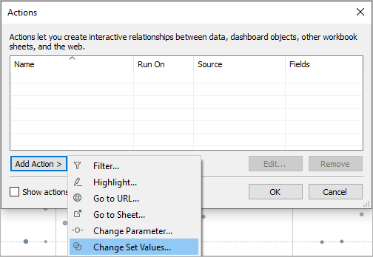

1. In the **Add/Edit Set Action** dialog box, specify a meaningful name for the action.
2. Select a source sheet or data source. The current sheet is selected by default. If you select a data source or dashboard you can select individual sheets within it.

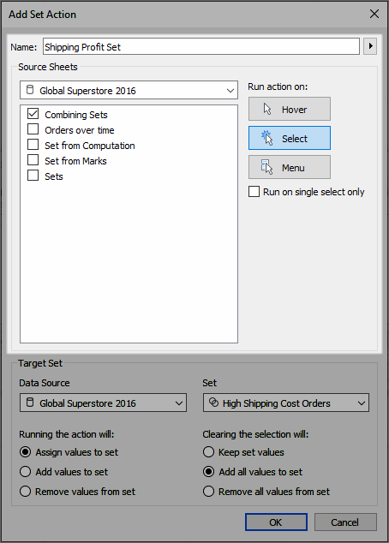

1. Select how users will run the action.
   * **Hover** - Runs when a user hovers the mouse cursor over a mark in the view.
   * **Select** - Runs when a user clicks a mark in the view. This option works well for set actions.
   * **Menu** - Runs when a user right-clicks (control-clicks on Mac) a selected mark in the view, then selects an option on the context menu.
2. Specify the target set. First, select the data source, and then select the set.

The sets available in the Target Set lists are determined by the data source that you select and the sets that you have created in the workbook that are associated with that data source.

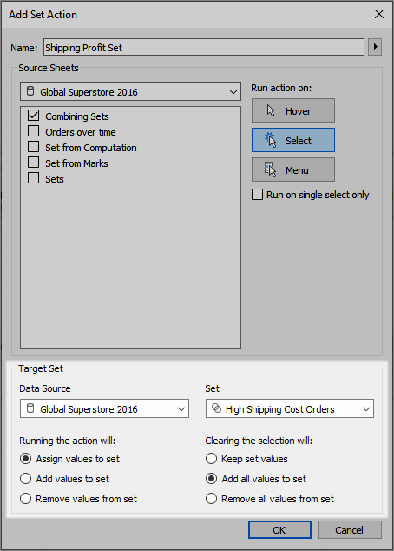

In this example, the target set is using *Global Superstore 2016* as the data source and *High Shipping Cost Orders* as the set.

1. Specify what happens when the action is run in the view:
   * **Assign values to set** - Replaces all values in the set with the values selected.
   * **Add values to set** - Adds individually selected values to the set.
   * **Remove values from set** - Removes individually selected values from the set.

**Note:** Selecting **Add values to set** or **Remove values from set** via the Set Action dialog modifies the values selected in the General tab of the set’s definition—just like **Assign values to set** does. This differs from the **Add to** and **Remove from** functionality available only in authoring mode via the set’s context menu in the tooltip. The latter unions or removes values to and from the set after the condition specified has been applied.

1. Specify what happens when the selection is cleared in the view:
   * **Keep set values** - Current values in the set remain in the set.
   * **Add all values to set** - Adds all possible values to the set.
   * **Remove all values from set** - Removes previously selected values from the set.
2. Click **OK** to save your changes and return to the view.
3. Test the set action by interacting with the visualization. Tweak some of the settings for the action to adjust the selection behavior as needed.



**Level Of Detail (LoD Expression):**

**Syntax:** { Type_Of_LOD Dimension : Aggregated_Measure }

An important feature in Tableau is Level of Detail expressions (also known as LOD expressions), which are used to compute values at the data source level and the visualization level. They are useful as they provide more control over the level of granularity you want to compute.

In this guide, you will learn how to discern the three different types of LOD calculations in Tableau:

* Fixed Level of Detail
* Include Level of Detail
* Exclude Level of Detail

In general, include LOD expressions are used to perform computations at a more granular level, whereas exclude LOD expressions are used for computations at a less granular level. Fixed LOD expressions are used when the level of granularity remains independent of the computation.

### Data

This guide uses the sample superstore data source available in the Tableau repository.

## Fixed Level of Detail

A fixed LOD expression is used to compute a value using specified dimensions without reference to the dimensions in the view. Follow the instructions below to create a fixed LOD expression to check the profit generated by each product category. In the view, you will have both product and sub-product categories. However, the profit will be displayed with respect to each product category, not subcategories.

### Steps

1. Click on the **Analysis** tab and select the **Create Calculated Field** option.
2. Write the fixed LOD expression to show the profit for every category. To do this, you’ll use the variables Profit and Category. This is shown below where the calculated field is named Fixed LOD - Profit Per Category.

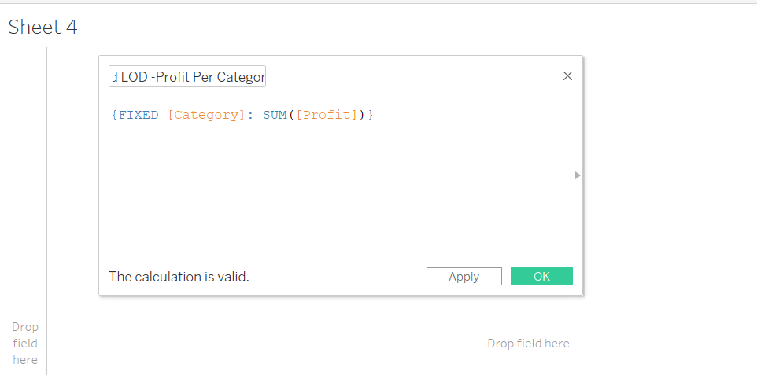

1. Drag the Category and Sub-Category variables in the **Rows** shelf.
2. Drag the calculated field created in Step 2 into the **Columns** shelf.

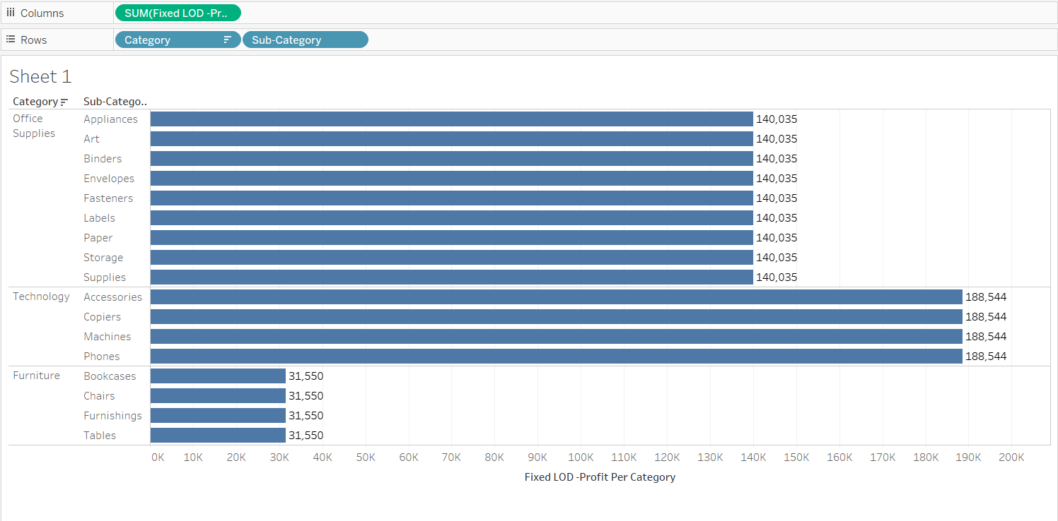

Even if you remove Category from the view, the measure will be calculated based on the dimensions specified in the expression. This means that the changes in the view do not impact the aggregation of the measure Profit, which is the feature of a fixed LOD expression.

## Include Level of Detail

An include LOD expression is used to compute values using specified dimensions in addition to the dimensions available in the view. Create an include LOD expression to visualize the average sales per product across different segments.

### Steps

1. To begin, click on the **Analysis** tab and select the **Create Calculated Field** option.
2. Write the include LOD expression to show the average sales per category. To do this, use the variables Sales and Product ID. The calculation is shown below where the calculated field is named Include LOD: Avg Sales Per Product.

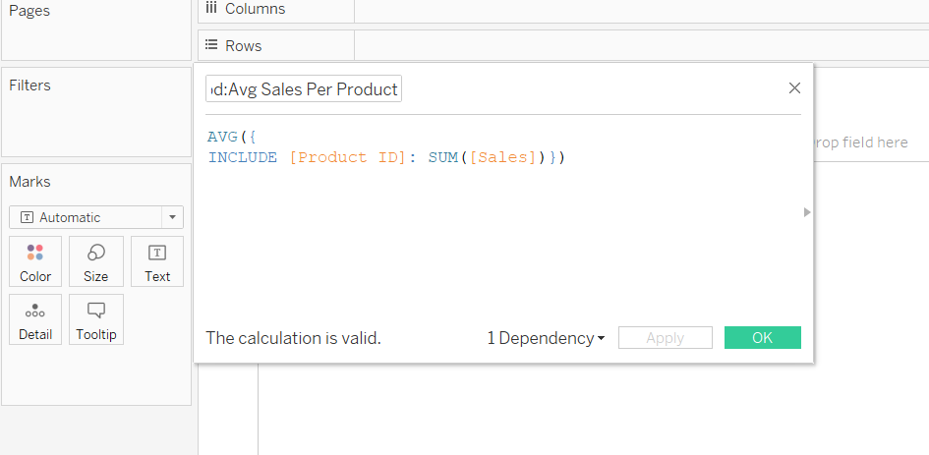

The calculation above expresses that at the granular Product ID level, summation of Sales will happen, while at the higher Segment level, aggregation will happen at the average level.

1. Drag the Segment variable into the **Rows** shelf and the calculated level of detail expression into the **Columns** shelf.
2. Turn the **Text** label on and sort in descending order. This will be fixed for each Segment as highlighted below.

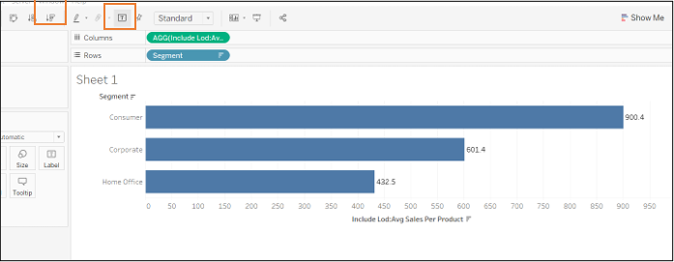

1. It is also possible to add more variables, like Category and Sub-Category, in the view along with the Segment variable. This will generate the following output.

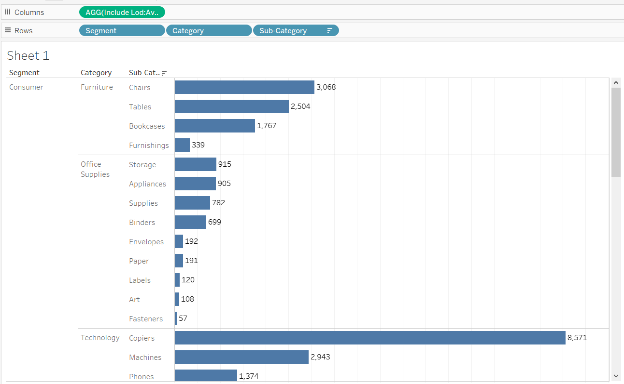

## Exclude Level of Detail

An exclude LOD expression is used to remove unwanted information from the data by creating an EXCLUDE function to omit the dimension at which aggregation is not required.

Create an exclude LOD expression to visualize the annual sales for each segment and category with respect to total sales while omitting the order date.

Steps:

1. Drag Segment and Category into the **Columns** shelf and Order Date into the **Rows** shelf.

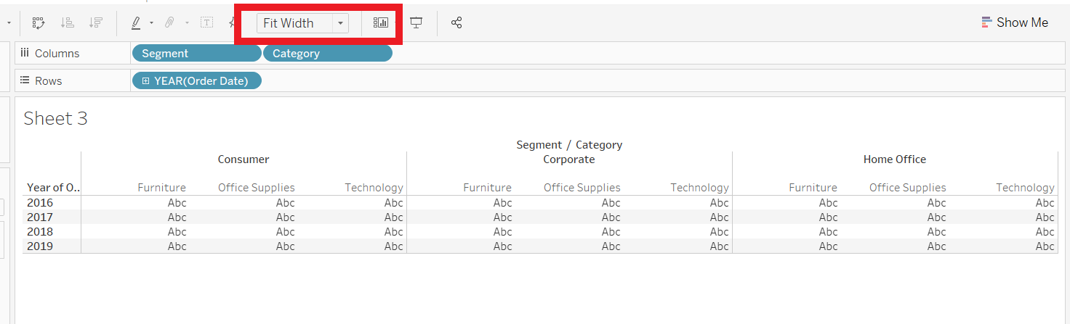

1. Click on the **Analysis** tab and select the **Create Calculated Field** option.
2. Write the exclude LOD calculation as shown below. This calculation will ignore the order date in the view.

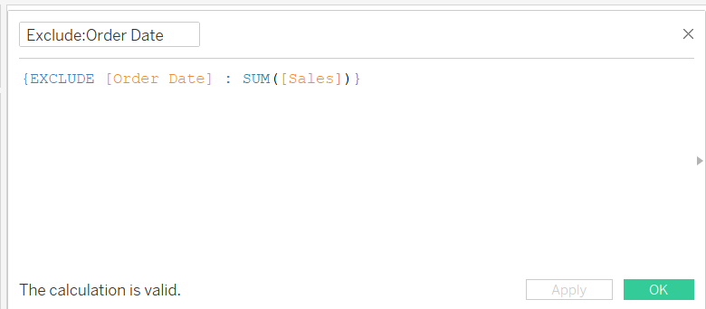

1. Drag the measure names into **Filter**, select the options Sales and Exclude: Order Date, and click **OK**.

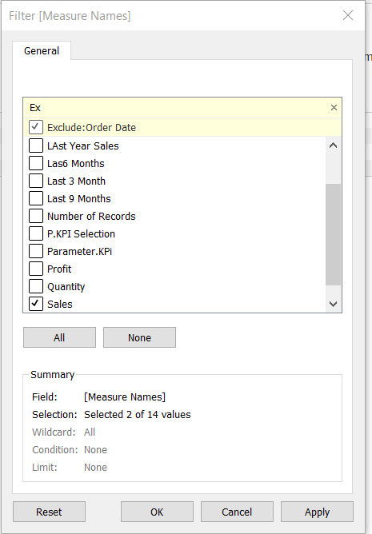

1. After applying the filter, drag **Measure Names** into the **Rows** shelf, next to the Order Date variable, and **Measure Values** into the label of the **Marks** card. This is shown below.

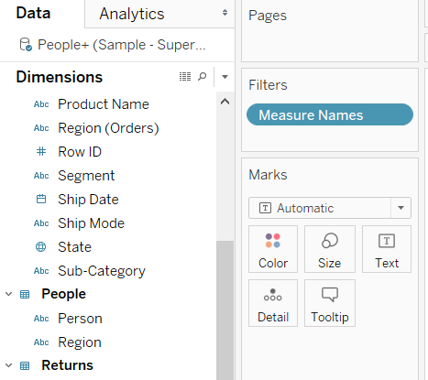

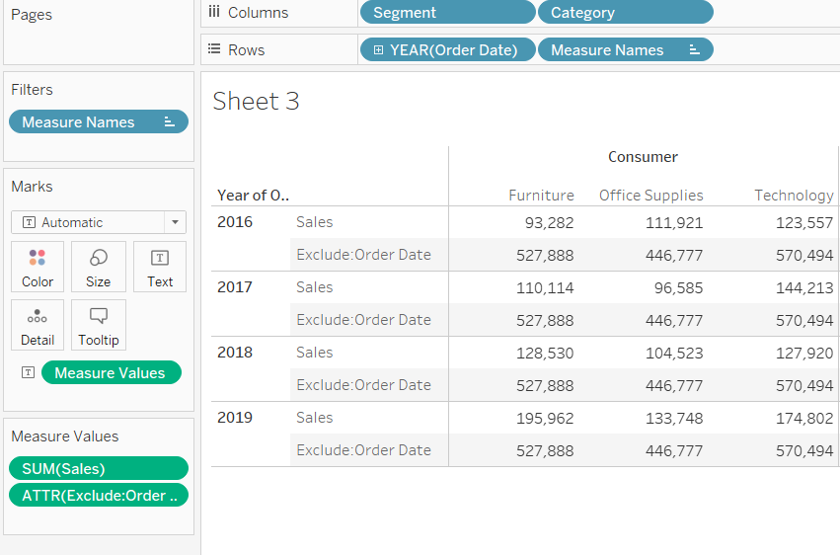

In the above output, you can see that the values of the excluded expression are replicated. This is because the total value remains the same as the Order Date is excluded. Also, this helps in comparing the contribution of individual year sales to the total sales across years.

**Tableau File Types and Folders:**

You can save your work using several different Tableau specific file types: workbooks, bookmarks, packaged data files, data extracts, and data connection files. Each of these file types are described below. For related details, see [Save Your Work](https://help.tableau.com/current/pro/desktop/en-us/save_savework.htm).

* **Workbooks (.twb) –** Tableau workbook files have the .twb file extension. Workbooks hold one or more worksheets, plus zero or more dashboards and stories.
* **Bookmarks (.tbm) –** Tableau bookmark files have the .tbm file extension. Bookmarks contain a single worksheet and are an easy way to quickly share your work. For more information, see [Save a bookmark(Link opens in a new window)](https://help.tableau.com/current/pro/desktop/en-us/save_savework.htm#Bookmark).
* **Packaged Workbooks (.twbx)** – Tableau packaged workbooks have the .twbx file extension. A packaged workbook is a single zip file that contains a workbook along with any supporting local file data and background images. This format is the best way to package your work for sharing with others who don’t have access to the original data. For more information, see [Packaged Workbooks](https://help.tableau.com/current/pro/desktop/en-us/save_savework_packagedworkbooks.htm).
* **Extract (.hyper or .tde)** – Depending on the version the extract was created in, Tableau extract files can have either the .hyper or .tde file extension. Extract files are a local copy of a subset or entire data set that you can use to share data with others, when you need to work offline, and improve performance. For more information, see [Extract Your Data](https://help.tableau.com/current/pro/desktop/en-us/extracting_data.htm).
* **Data Source (.tds) –** Tableau data source files have the .tds file extension. Data source files are shortcuts for quickly connecting to the original data that you use often. Data source files do not contain the actual data but rather the information necessary to connect to the actual data as well as any modifications you've made on top of the actual data such as changing default properties, creating calculated fields, adding groups, and so on. For more information, see [Save Data Sources](https://help.tableau.com/current/pro/desktop/en-us/export_connection.htm).
* **Packaged Data Source (.tdsx) –** Tableau packaged data source files have the .tdsx file extension. A packaged data source is a zip file that contains the data source file (.tds) described above as well as any local file data such as extract files (.hyper or .tde), text files, Excel files, Access files, and local cube files. Use this format to create a single file that you can then share with others who may not have access to the original data stored locally on your computer. For more information, see [Save Data Sources](https://help.tableau.com/current/pro/desktop/en-us/export_connection.htm).

These files can be saved in the associated folders in the My Tableau Repository directory, which is automatically created in your My Documents folder when you install Tableau. Your work files can also be saved in other locations, such as your desktop or a network directory.

**Tableau Data Extract File (.TDS, .TDSX)**

You can extract your data sources in the web (without using Tableau Desktop) to improve data source performance and support additional analytical functions. When you extract your data source, Tableau will copy the data from your remote data store to Tableau Server or Tableau Cloud. To learn more about the benefits of extracting your data, see [Extract Your Data](https://help.tableau.com/current/pro/desktop/en-us/extracting_data.htm). In the web, you can extract while in Web Authoring or while in Content Server.

Create extracts in Web Authoring

You can create extracts directly in web authoring with default extract settings.

Extract an Embedded Data Source in Web Authoring

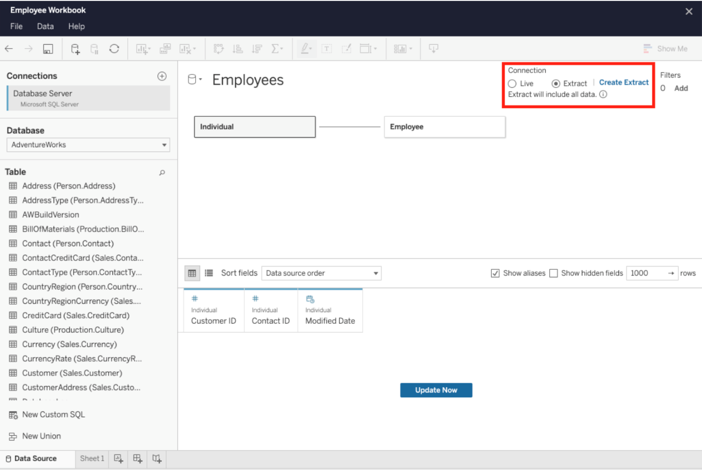

To create an extract in web authoring:

Tip: It is recommended to finalize your data model before you create the extract. Extract creation may take a long time and any changes to your data model, such as adding new logical tables, will invalidate the extract.

1. Click the Data Source tab in the bottom left corner of the web authoring pane. For new workbooks, you will start in the Data Source tab.
2. In the top-right corner, change the connection type from Live to Extract.
3. Click Create Extract. You will see the Creating Extract dialog box.

Extract creation might take a long time and you can close your authoring session while the extract is being created. To ensure your extract creation is not lost, in the dialog box, click Notify Me When Complete to specify a location for the extracted workbook to be saved. If your extract succeeds, your workbook will be saved to the specified location and you will be notified that you can continue your web authoring session. If your extract creation fails, you will be notified that the extract could not be created and you can restore your unsaved changes by reopening the original workbook in web authoring.

Define your Extract Settings

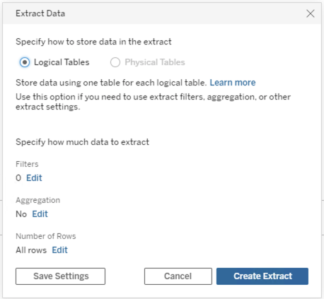

More Info: <https://help.tableau.com/current/server/en-us/datasource_extract.htm>